TRUCK DRILLING MACHINE OPERATING MANUAL
Model: Truck Multi-Spindle Drilling Machine (48-Spindle Configuration)
Version: 1.0
Effective Date: January 2025
Document Classification: Technical / Operational

TABLE OF CONTENTS
- General & Legal Information
- Machine Identification & Overview
- Technical Specifications & Data
- Safety Information & Warnings
- Transport, Installation & Commissioning
- Operating Procedures
- Maintenance & Lubrication
- Troubleshooting & Alarm Codes
- Spare Parts & Consumables
- Appendices

1. GENERAL & LEGAL INFORMATION

1.1 Manufacturer Details
Item | Details
Manufacturer | Accurate Machines & Accessories (Pvt) Ltd.
Address | Ambattur, Chennai – 600 098, India
Contact Number | [PLACEHOLDER: Insert contact details]
Email | [PLACEHOLDER: Insert email]
Website | [PLACEHOLDER: Insert website]

1.2 Machine Purpose & Application
This Truck Drilling Machine is designed for high-precision drilling of clutch facing components made of composite materials (organic and inorganic fibers with thermosetting resins). The machine conforms to Valeo quality standards and is intended for automated manufacturing environments.
Key Application: Drilling multiple holes in clutch facings as per Valeo specifications with automatic poka-yoke quality checks.

1.3 Regulatory Compliance & Standards
This machine is designed and manufactured in accordance with the following Indian and International standards:
- IS 4571:1968 – General Safety Requirements for Machinery
- IS 12100-1:2003 – Safety of Machinery (General Principles of Design)
- IS 12100-2:2003 – Safety of Machinery (Technical Principles and Specifications)
- IS 13598:2013 – Industrial Safety Management Systems
- ISO 14121 – Risk Assessment & Reduction
- Valeo General Equipment Specifications (D/Meth/025 Rev. 12)

1.4 Warranty & Liability
[PLACEHOLDER: Insert warranty period, coverage details, and limitation of liability clauses]

2. MACHINE IDENTIFICATION & OVERVIEW

2.1 Machine Identification Data
Parameter | Specification
Machine Type | Truck Multi-Spindle Drilling Machine
Configuration | 48-Spindle (Gang Drilling)
Serial Number | [PLACEHOLDER: Insert serial number in format: AMA-TDM-YYYY-XXXXX]
Year of Manufacture | 2025
Control System | Mitsubishi FX5U PLC + ProFace 10" HMI
Electrical Supply | 3-Phase, 415V AC, 50 Hz
Drawing Reference | D/Meth/050/Truck Drilling/CH/01 Rev. 1

2.2 Machine Layout & Main Components
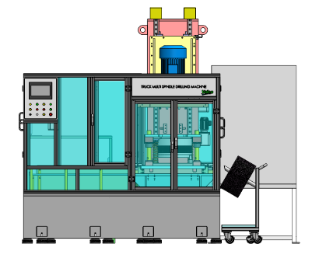
Main Subsystems:
- Loading & Feeding System – V-feeder with servo control
- Drilling Head Assembly – Multi-spindle rotating head (1460 RPM)
- Hydraulic System – Clamping and servo control circuits
- Pneumatic System – Component handling and poka-yoke actuation
- Control System – PLC, HMI, Safety interlocks, Door interlocks
- Dust Collection System – Integrated chip and coolant recovery
- Safety System – Emergency stop, safety doors, interlock switches

2.3 Typical Product Specifications
The machine processes clutch facings with the following dimensional range:
Parameter | Minimum | Maximum
Clutch Facing Outside Diameter | 280 mm | 430 mm
Clutch Facing Thickness | 2.8 mm | 6.2 mm
Number of Holes | 24 Nos. | 54 Nos.
Hole Diameter | 7.75 mm | 14.5 mm
Rivet Hole Thickness | 0.9 mm | 2.1 mm
Hole Position Runout (Tolerance) | ±0.1 mm | ±0.1 mm
Concentricity (Maximum Offset) | — | 0.8 mm

3. TECHNICAL SPECIFICATIONS & DATA

3.1 Dimensional Data
Parameter | Specification | Unit
Machine Length | 2.315 | Meters
Machine Width | 2.103 | Meters
Machine Height | 3.048 | Meters
Total Machine Weight | 1.0 | Ton (1000 kg)

3.2 Power & Energy Consumption
Parameter | Specification | Remarks
Total Installed Power | 10 | kW
Motor Rating (Spindle Drive) | [PLACEHOLDER] | kW @ 1460 RPM
Servo Motor (Feed) | [PLACEHOLDER] | kW
Servo Motor (Drill Head Movement) | [PLACEHOLDER] | kW
Hydraulic Pump Motor | [PLACEHOLDER] | kW
Pneumatic Compressor Requirement | 5–6 | Bar (minimum)
Average Daily Energy Consumption | [PLACEHOLDER] | kWh

3.3 Hydraulic System Specifications
Circuit | Max. Pressure | Max. Flow | Application
Main (Spindle Clamping) | 105 BAR | 8 LPM | Workpiece clamping & servo control
Cooling & Lubrication | 10 BAR | 30 LPM | Tool cooling & spindle lubrication
Hydraulic Fluid Specification:
- Type: [PLACEHOLDER: ISO VG 46 Anti-wear Hydraulic Fluid / equivalent]
- Capacity: [PLACEHOLDER]
- Replacement Interval: [PLACEHOLDER]

3.4 Pneumatic System Specifications
Parameter | Specification
Operating Pressure | 5–6 Bar
Supply Source | Plant Compressed Air System
Filtration | 5-micron filter (minimum)
Desiccant Dryer | Required for humid climates
Solenoid Valve Rating | 24 V DC
Actuators | Festo pneumatic servo drives

3.5 Electrical System Specifications
Parameter | Specification
Mains Supply | 3-Phase, 415V AC, 50 Hz, 16A (minimum)
Control Voltage | 24 V DC (UPS-backed for safety functions)
PLC Controller | Mitsubishi FX5U Series
HMI | ProFace 10" touchscreen panel
Emergency Stop | 24 V DC solenoid cut-off circuit
Control Panel IP Rating | IP65 (dust-proof)
Safety Certification | Decra/Omron/Pilz certified

3.6 Environmental Operating Conditions
Parameter | Specification | Remarks
Ambient Temperature Range | +5°C to +40°C | Optimal operation
Relative Humidity | 20% to 85% | Non-condensing
Noise Level | <75 dB | At full operation
Vibration Level | [PLACEHOLDER] | At operating speed

3.7 Performance Metrics & Acceptance Criteria
Function | Specification | Unit | Tolerance
Spindle Rotation Speed | 1460 | RPM | Minimum
Production Capacity | 600 | Parts/Hour | Minimum
MTBF (Mean Time Between Failures) | 8 | Hours | Minimum
TRP (Total Run Percentage) | 85 | % | Minimum
MTTR (Mean Time To Repair) | 1 | Hour | Maximum
Changeover Time (Tooling) | 30 | Minutes | Maximum
Dimensional Accuracy (Thickness Under Rivet Head) | ±0.05 | mm | Cp/Cpk >1.6
Concentricity (PCD Eccentricity) | — | — | Cmk = 2.0 minimum

4. SAFETY INFORMATION & WARNINGS

4.1 General Safety Precautions
⚠️ WARNING: This is a high-speed, precision drilling machine with rotating cutting tools and moving parts. Failure to follow safety procedures may result in serious injury or death.
Before Operating this Machine:
- Read this entire manual and understand all warnings and instructions
- Receive proper training from an authorized trainer
- Always wear appropriate Personal Protective Equipment (PPE)
- Never operate this machine while fatigued or under the influence of alcohol/drugs
- Keep hands, long hair, loose clothing, and jewelry away from moving parts
- Never reach into the machine during operation
- Always use provided jigs, fixtures, and clamping devices as specified

4.2 Personal Protective Equipment (PPE)

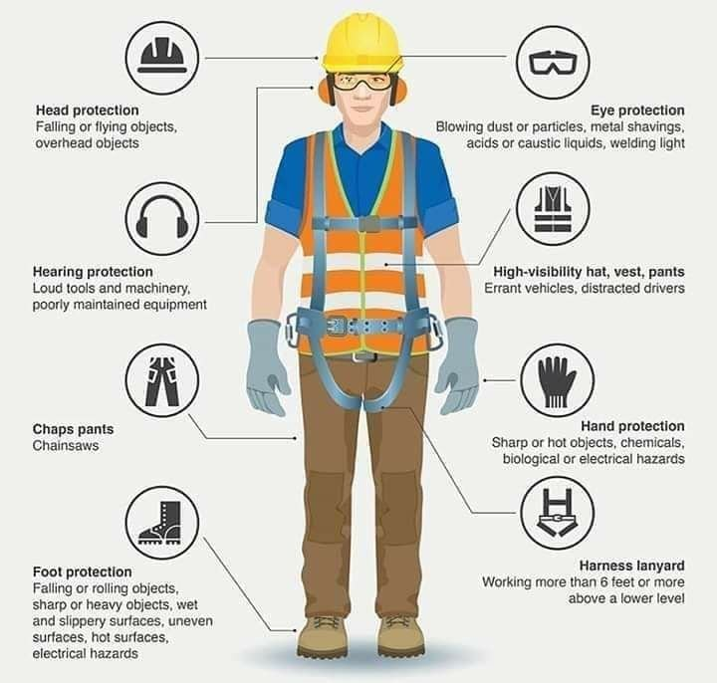
Mandatory PPE:
PPE Item | Specification | Reason
Safety Glasses | Anti-scratch, polycarbonate lens | Chip/dust protection
Ear Protection | Noise level <75 dB; use when extended exposure | Hearing protection
Hand Gloves | Cotton or leather (remove near rotating spindle) | Oil and chip handling
Safety Shoes | Steel-toed, slip-resistant | Foot protection from dropped parts
Work Apron | Durable synthetic material | Protection from coolant splash
Hair Covering | For operators with long hair | Prevent entanglement

4.3 Safety Features of the Machine
The machine is equipped with the following safety systems:
- Safety Interlocked Doors – Machine cannot run if safety doors are open
- Emergency Stop (E-Stop) Button – Red mushroom button at operator station; stops all motion immediately
- Automatic Machine Stop – Triggers on detection of any failure or abnormal condition
- Light Signal Indicator – Visual alarm display on HMI and operator station
- Poka-Yoke Sensors – Prevent component overlap, detect missing holes, verify concentricity
- Dust Collection System – Integrated dust suppression and chip removal
- Tool Clamping Safety – Automatic tool clamping/declamping with servo verification
- Drill Head Locking Pin – Manual safety pin to lock drill head before maintenance

4.4 Lock-Out & Tag-Out (LOTO) Procedures
ENERGY ISOLATION POINTS:

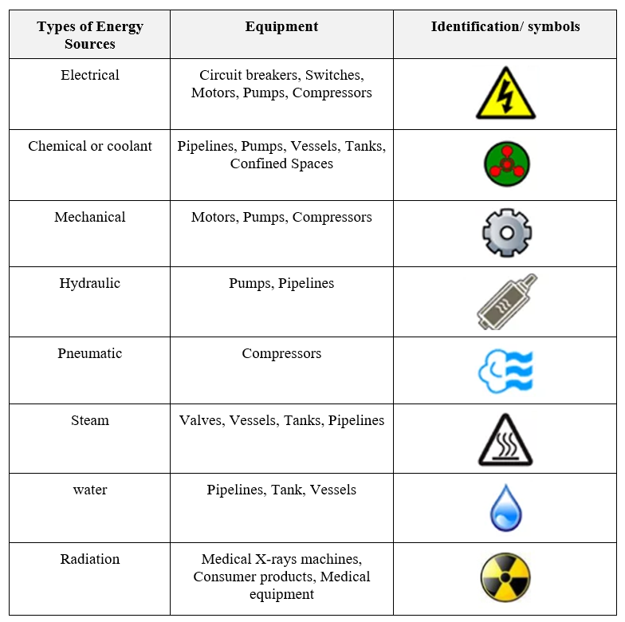
Energy Type | Isolation Method | Location | Lockable | Procedure
Electrical | Main isolator switch | Control panel (left side) | Yes | Switch OFF + Lock with padlock
Hydraulic (Main) | Ball valve on pump discharge | Hydraulic manifold | Yes | Close fully + Lock if possible
Hydraulic (Lubrication) | Ball valve on lubrication circuit | Lubrication manifold | Yes | Close fully
Pneumatic | Solenoid dump valve | Pneumatic control block | No | Energize "Dump" switch on HMI
Mechanical | Drill head locking pin | Above drill head assembly | Yes | Insert pin + Lock pin slot
LOTO Procedure Before Maintenance:
- Press EMERGENCY STOP button – Red button at operator station
- Switch OFF Main Electrical Isolator – Located on control panel left side; turn clockwise to OFF position
- Insert padlock through isolator switch lever – To prevent accidental restart
- Isolate Hydraulic Pressure – Close main pump discharge valve on hydraulic manifold; lock if slot available
- Isolate Pneumatic Supply – Switch HMI "Pneumatic Dump" to ON; listen for pressure release hiss
- Insert Drill Head Locking Pin – Locate pin slot above drill head; insert safety pin; secure with lock pin
- Verify Zero Energy State – Use pressure gauge to confirm hydraulic pressure drops to zero; listen for silence
- Place LOTO Tag – Attach personal LOTO tag to isolator and locking pin with your name and timestamp
- Remove Power Cord (Optional) – For extended maintenance, unplug power cord at wall socket
LOTO Procedure After Maintenance:
- Verify all tools removed from machine
- Verify all access panels closed and secured
- Remove all LOTO tags and locks
- Switch ON main electrical isolator
- Slowly open hydraulic pump discharge valve
- Switch HMI "Pneumatic Dump" to OFF
- Remove drill head locking pin
- Press RESET on HMI to clear any stored alarms
- Perform pre-start checks (Section 6.1) before restarting

4.5 Prohibited Operations
🛑 NEVER DO THE FOLLOWING:
- Operate the machine without authorized training and certification
- Remove or disable any safety interlocks, guards, or door switches
- Reach into the machine during operation
- Run the machine with safety doors open
- Attempt to clear chips or jams while machine is running
- Lubricate or adjust tools during spindle rotation
- Modify machine parameters without supervisor approval
- Use the machine for purposes other than specified drilling operations
- Override poka-yoke error signals to force operation
- Load or unload components at unsafe speeds or positions

5. TRANSPORT, INSTALLATION & COMMISSIONING

5.1 Transport & Handling

5.1.1 Lifting & Rigging

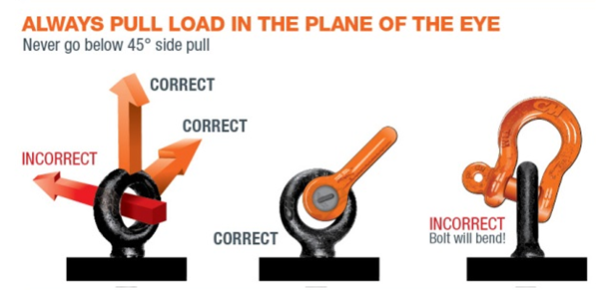
- Lifting Method: Four eye bolts (M16) installed on machine top frame for lifting
- Rigging Equipment: 2–4 ton capacity slings rated for industrial machinery
- Lifting Speed: Slow and controlled; maximum 0.5 m/s
- Personnel: Minimum 2 certified riggers required
Lifting Points Location:
- Front-left and front-right: [PLACEHOLDER: Describe coordinates]
- Rear-left and rear-right: [PLACEHOLDER: Describe coordinates]

5.1.2 Transportation Safety
- Machine must be secured to transport vehicle using resilient lashings and spacers
- Cover machine with protective tarpaulin to prevent weather damage
- Avoid sudden acceleration, braking, and sharp turns during transport
- Machine should be transported in horizontal position (NO tilting)
- Remove any loose components, tool holders, or jigs before transport
- Inspect for damage upon delivery before unloading

5.2 Installation & Site Preparation

5.2.1 Installation Requirements
Requirement | Specification
Floor Loading Capacity | Minimum 1.5 ton/m² (concentrated)
Floor Evenness | ±5 mm tolerance over 3-meter span
Anchoring | [PLACEHOLDER: Describe anchoring method if applicable]
Space Clearance | 1 meter on all sides for maintenance access
Environmental Conditions | +5°C to +40°C, <85% RH (non-condensing)

5.2.2 Electrical Installation
- Supply Connection: By certified electrician only; 3-Phase 415V AC, 50 Hz
- Earth Connection: Machine frame must be grounded to plant earth (<5 ohm resistance)
- Control Panel Location: Dry, accessible location; minimum 1 meter from machine for operator reach
- Emergency Stop Button: Positioned at operator station; red color, easily accessible
- UPS Backup: 24 V DC emergency stop circuit should be backed by UPS for minimum 10-second runtime

5.2.3 Hydraulic System Installation
- Install main hydraulic power pack adjacent to machine (within 2 meters)
- All hose runs should have drip trays underneath
- Tank capacity: [PLACEHOLDER]
- Filtration: 10-micron system with differential pressure indicator

5.2.4 Pneumatic System Installation
- Connect plant compressed air to machine input via 5-micron filter
- Supply pressure: 5–6 bar (regulated at source)
- Install pressure gauge on supply line for monitoring
- Desiccant dryer recommended for humid climates (>70% RH)

5.3 Commissioning Procedure

5.3.1 Pre-Commissioning Checklist
- [ ] Machine physically installed and secured
- [ ] All electrical connections verified by certified electrician
- [ ] Hydraulic system filled with specified fluid; no leaks detected
- [ ] Pneumatic system pressurized and tested; all joints tight
- [ ] Control panel powered up; HMI display responsive
- [ ] All poka-yoke sensors functioning (verified with test blocks)
- [ ] Drill head rotates freely at zero pressure; no mechanical binding
- [ ] Safety doors close properly; interlock switches respond
- [ ] Emergency stop button tested; stops all motion immediately
- [ ] Dust collector system running; positive suction at spindle

5.3.2 Commissioning Tests
- No-Load Spindle Rotation Test – Run spindle at 1460 RPM for 10 minutes; monitor vibration and noise
- Servo Movement Test – Jog feed servo forward/backward and drill head up/down; verify smooth motion
- Pressure Test – Monitor hydraulic pressure during clamping cycle; verify within specification
- Cycle Test (Empty) – Run 5 complete cycles without component to verify sequence and timing
- Cycle Test (Trial Components) – Run 20 cycles with trial clutch facing; measure hole accuracy and verify poka-yoke checks
- Production Run Test – Run minimum 100 parts at rated speed (600 p/h); verify MTBF and TRP targets

6. OPERATING PROCEDURES

6.1 PRE-START VERIFICATION CHECKLIST

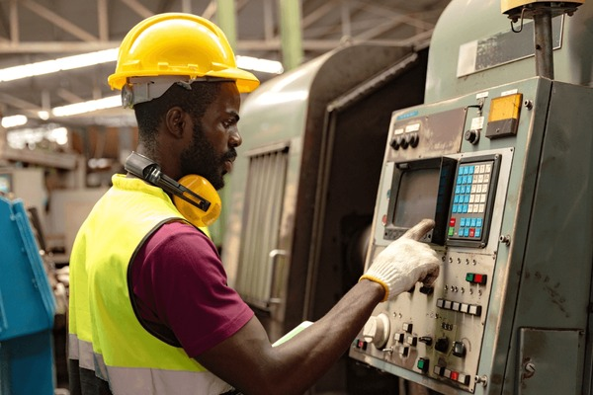
Timing: Complete checklist before every shift start or after machine shutdown >30 minutes
Procedure Step-by-Step:

Step 1: Verify Main Electrical Isolator is ON
- Location: Control panel, left side, red/black switch lever
- Status: Switch lever should be pointing UP (ON position)
- Action: If OFF, switch to ON position; proceed only after HMI powers up

Step 2: Check Electrical Earth (Ground)
- Location: Main isolator panel, earth connection bolt (marked with green/yellow label)
- Status: Verify bolt is tight and shows no corrosion or white powder deposit
- Tool Required: Insulated screwdriver or multimeter for resistance check (target: <5 ohm to plant earth)
- Action: If loose or corroded, tighten or clean; report to maintenance if resistance >5 ohm

Step 3: Verify HMI Ready & Responsive
- Location: ProFace 10" touchscreen on control panel, right side
- Action:
  - Observe startup sequence: Mitsubishi FX5U logo → Main menu screen
  - Verify all indicator lights illuminated: Power (Green), Ready (Blue), Alert Status (Yellow/Red if abnormal)
  - Touch main screen to confirm responsiveness; should show menu options
  - If screen frozen or no response, perform soft reset: Hold Reset button on HMI for 3 seconds
  - If still unresponsive, switch OFF isolator, wait 30 seconds, switch ON again (cold restart)

Step 4: Check Component Buffer Level (Loading Area)
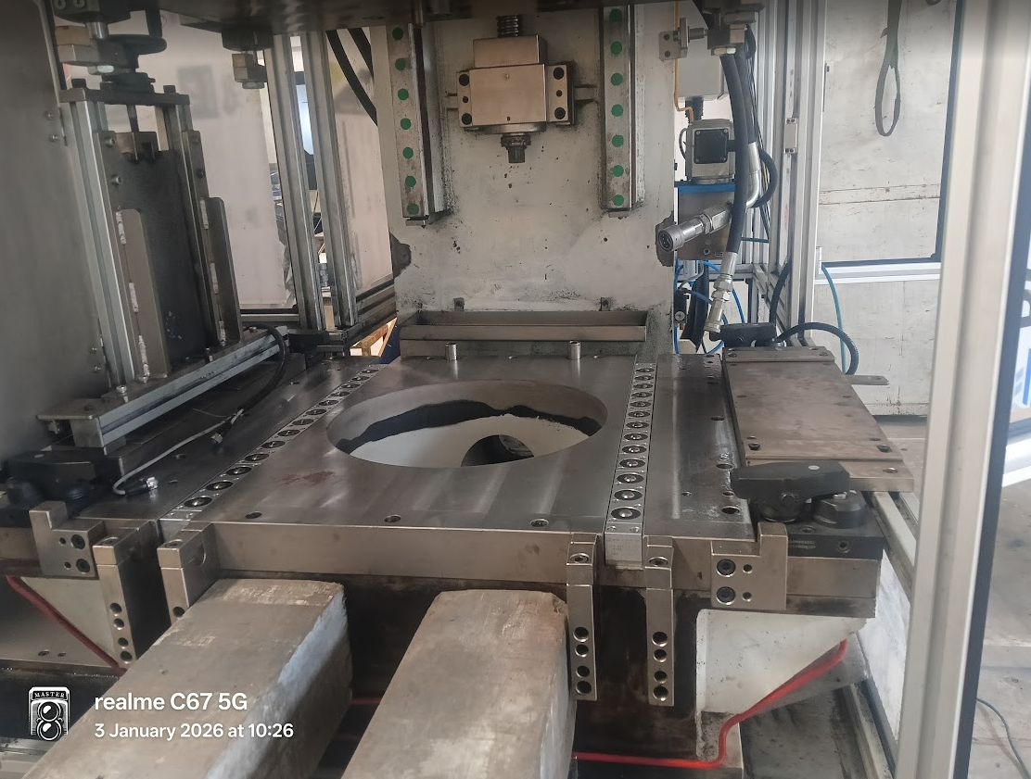

- Location: Loading tray assembly (top-left of machine)
- Status: Minimum 100–150 clutch facings should be stacked in loading area
- Poka-Yoke Sensor: Located at bottom of loading stack; should be covered (facings above minimum) for green light indicator
- Action:
  - If buffer below minimum: Load 100–150 new facings manually into tray
  - If green light indicator remains red even with full buffer: Check sensor lens for dust; clean with soft cloth if needed; report to maintenance if light remains red
  - Do NOT start machine if buffer sensor shows red alert

Step 5: Verify Component Loading Area is Clear & Ready
[IMAGE PLACEHOLDER: Clean loading area with proper component orientation]
- Location: V-feeder component entry point (center-left of machine)
- Status: Area should be empty; no components jammed or stuck in feeder
- Action:
  - Visually inspect feeder path from loading tray to drill jig; no debris or broken component pieces
  - Push feeder manually by hand (machine OFF) to verify smooth movement (servo powered OFF at this stage)
  - Verify groove poka-yoke sensor: Should show green light indicator when facing with groove is placed against feeder (sensor at +45° angle on feeder)
  - If feeder movement is jerky or sticky, report to maintenance; do NOT proceed

Step 6: Inspect Component Overlap Area (Drill Jig Entry)

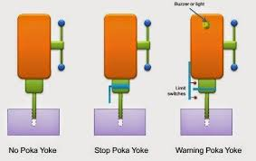
- Location: Drill jig seating area (below spindle head)
- Status: Jig should be empty; no overlapping or stacked components visible
- Overlap Poka-Yoke Sensor: Located above jig platform; detects when two components are stacked (height sensor)
- Action:
  - Visually confirm jig is empty
  - Place a single test facing in jig
  - Machine should detect single component: Green light on HMI overlay sensor indicator
  - Place a second test facing on top of first (overlay condition)
  - Machine should detect overlap: Red light and audible alarm on HMI
  - Remove test facing; jig should return to green light
  - If sensor does not respond to overlay condition, report to maintenance; do NOT proceed

Step 7: Check Output/Ejection Area

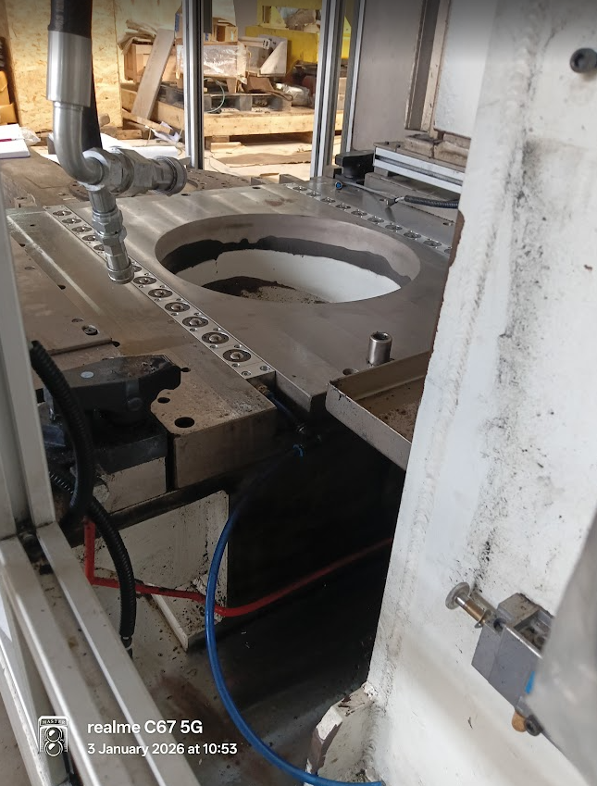
- Location: Opposite side of drill jig (right side of machine)
- Status: Output collection area should be empty and ready to receive drilled components
- Ejection Path: Should be clear; no obstructions, no spillage from previous batch
- Collection Bin: Positioned directly under output chute; secure and ready
- Action:
  - Clear any spillage or residual components from output area
  - Position collection bin at output chute (center alignment)
  - Verify bin is empty and clean; ready to receive drilled facings

Step 8: Verify Clamping Position & Poka-Yoke Sensor

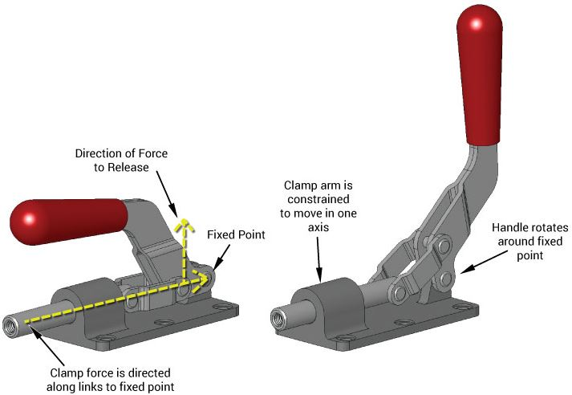
- Location: Drill jig clamping assembly (below spindle)
- Status: Clamp should be in fully open position (relaxed state) at machine idle
- Clamping Poka-Yoke: Proximity sensor detects clamp position
- Action:
  - Visually confirm clamp arms are fully open (180° position)
  - Green indicator light should be visible on HMI clamping status
  - If clamp is partially closed or stuck, manually open by hand; report to maintenance if resistance felt
  - Attempt manual clamping cycle (if available on HMI test menu): Press "Test Clamp" button; verify clamp closes smoothly, then opens after 2-second hold
  - If clamp does not respond or moves jerkily, do NOT proceed; report to maintenance

Step 9: Verify Top Drill Head Locking Pin Status

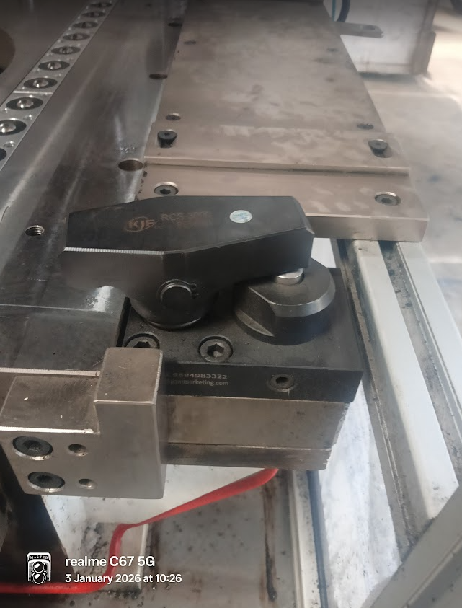
- Location: Above multi-spindle drilling head, center-top
- Status: Locking pin should be INSTALLED & LOCKED during pre-start (safety requirement)
- Purpose: Prevents accidental drill head movement during component loading or inspection
- Action:
  - Visually locate locking pin above drill head; should be inserted in locking slot (horizontal position)
  - Verify pin is fully seated; no gaps visible between pin and slot
  - Lock pin should have a padlock or keyed lock in place
  - If pin is missing or loose: DO NOT PROCEED; locate spare pin from maintenance kit and install; lock with padlock
  - This pin MUST remain installed until all component loading is complete and operator is ready to trigger first cycle start

Step 10: Check Drill Head Oil Line – Input & Output Hoses

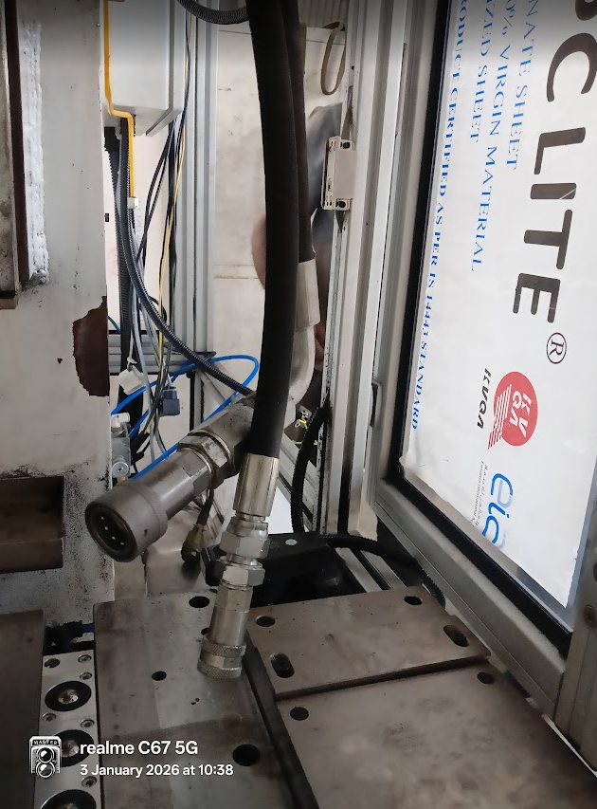
- Location: Top-rear of drill head assembly, two hoses: Pressure (Red) & Return (Blue)
- Status: Both hoses should be tightly connected; no visible leaks, cracks, or bulging
- Pressure Line (Red):
  - Should be firm to touch (pressurized during cycle only)
  - Connection nut should not be loose; use spanner for verification if needed
  - No weeping or drops of oil visible
- Return Line (Blue):
  - Should feel warm during idle (passive return flow)
  - Connection should be tight; no splashing or spraying
  - Should return to reservoir tank smoothly
- Action:
  - Gently tug both hoses to confirm they are firmly connected
  - Wipe both connection points with clean cloth; inspect for oil seepage
  - If either hose shows leaking, cracks, or bulging: STOP IMMEDIATELY; report to maintenance; do NOT use machine
  - Monitor hose temperature (touch gently with palm) – should be warm but not burning hot (target: <50°C)
  - If excessively hot, notify maintenance; may indicate internal blockage or pump issue

Step 11: Verify Dust Collector System is Running
[IMAGE PLACEHOLDER: Dust collector unit showing suction points, filter, and discharge]

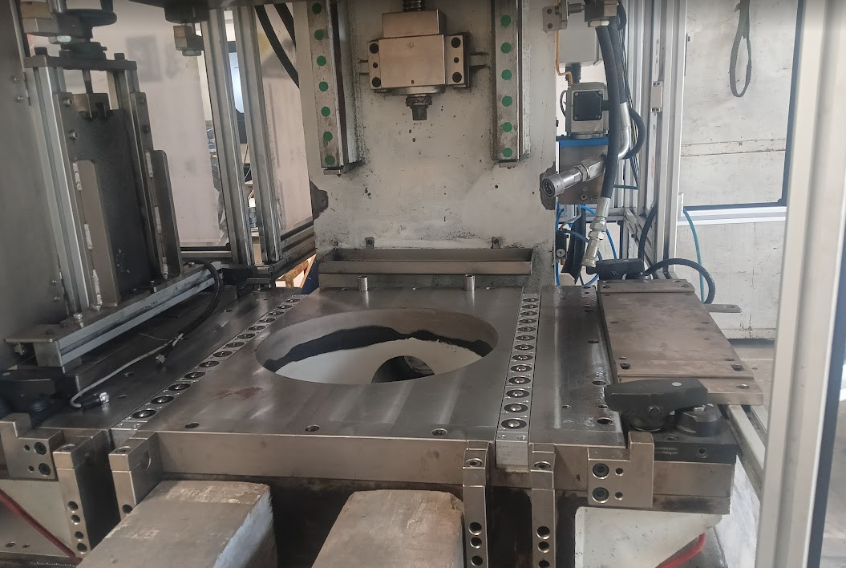
- Location: Dust collection unit (adjacent to main machine body, typically right side)
- Status: Motor should be running and producing suction at spindle drill area
- Visual Indicators:
  - Dust collector motor light (green indicator) should be illuminated on control panel
  - Sound check: Audible vacuum suction sound from dust lines near spindle
  - Filter observation: Dust should be visibly accumulating in collection bag/cartridge
- Action:
  - Switch ON dust collector motor (if not already running): Locate "Dust Collector" switch on HMI main menu or control panel; select ON
  - Verify suction by placing hand near spindle dust outlet (machine OFF) – should feel strong air pull inward
  - Check collection bag for fullness: If >75% full, empty bag before shift to maintain suction efficiency
  - Verify filter element is clean (visual check through sight glass): Whitish dust layer = normal; dark/clogged appearance = replace filter
  - If no suction detected: Check filter blockage first; then check for hose disconnection; report to maintenance if issue persists

Step 12: Final Visual Inspection
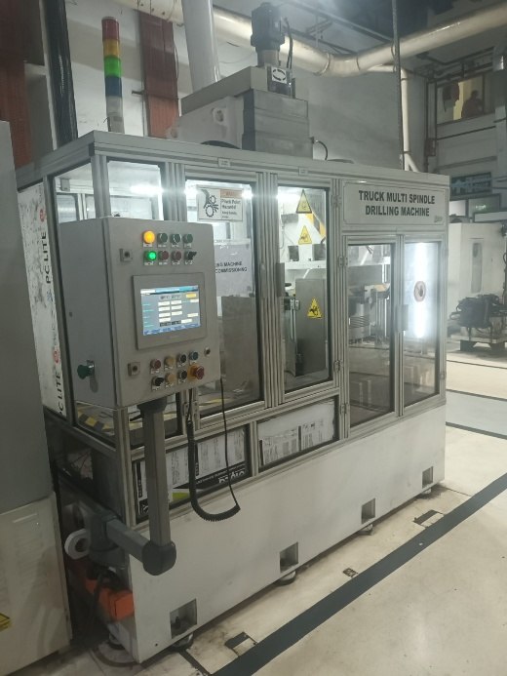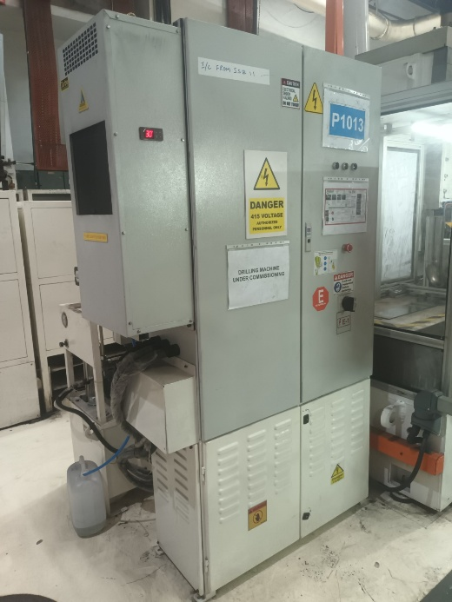
- Do a complete walk-around of the machine (360° view)
- Verify all safety doors are closed and interlocked
- Confirm no loose tools, parts, or materials on machine bed or underneath
- Check floor around machine: dry, no spills, no tripping hazards
- Verify operator station is organized; emergency stop button clearly visible and accessible

6.2 NORMAL OPERATING CYCLE (Machine Operation Sequence)

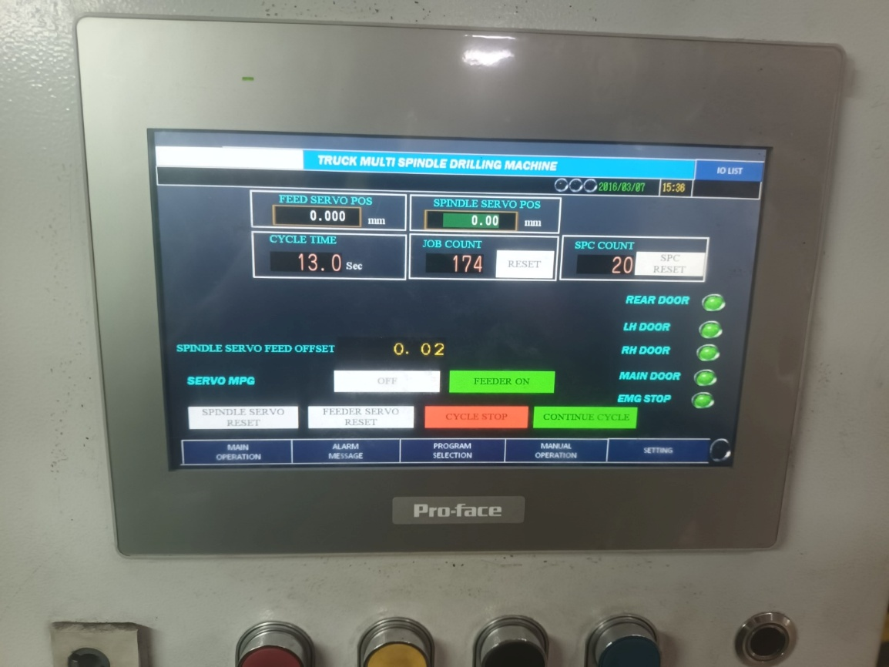

6.2.1 Cycle Initiation
Pre-Requisite: All pre-start checks (Section 6.1) completed with green status
Operator Actions:
- Ensure drill head locking pin is INSTALLED and LOCKED (safety requirement)
- Load components manually into loading tray (100–150 pieces) – repeat as needed
- Proceed to HMI; main menu should be visible
- Touch "START PRODUCTION" button on HMI
- System will verify:
  - Buffer sensor status: Green (minimum components present)
  - Clamp position: Open (jig ready)
  - Safety doors: All closed and interlocked
- If any check fails: Red alarm light + audible buzzer; correct issue and retry
- If all checks pass: Remove drill head locking pin and proceed to cycle start

6.2.2 NORMAL PRODUCTION CYCLE – STEP-BY-STEP FLOW

PHASE 1: COMPONENT LOADING (Duration: ~2–3 seconds)
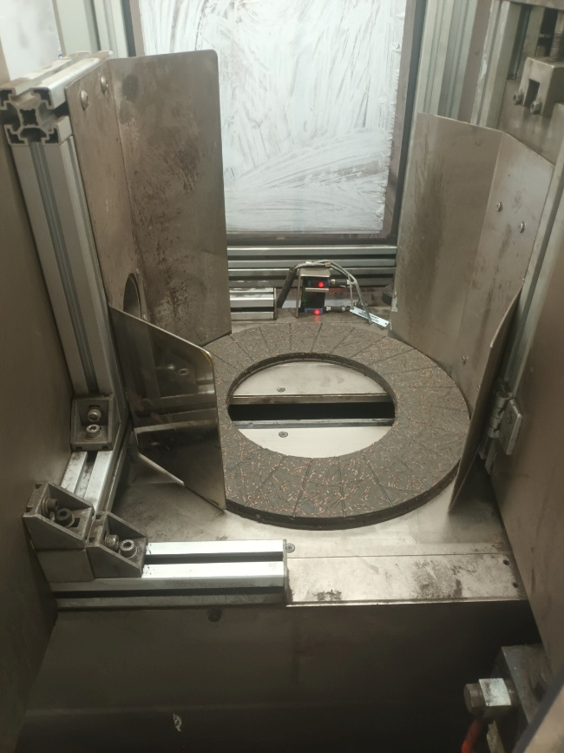

Step 1.1 – Component Loading Area → Component Feeder
- Actor: Pneumatic solenoid valve + Festo servo drive (Component Feeder)
- Action:
  - Solenoid energizes; pneumatic pressure pushes component from loading tray into V-feeder
  - V-feeder servo motor activates; component pushed into feeder channel
  - Component should align with groove poka-yoke sensor (groove detection)
- Poka-Yoke Check:
  - Groove poka-yoke sensor checks if component orientation is correct (groove present on top)
  - Status: GREEN = groove detected, component correctly oriented → proceed
  - Status: RED = no groove detected, component inverted or defective → machine stops; operator removes and reloads
- Timing: 2–3 seconds
- Outcome: Component now seated in V-feeder, ready for center positioning

PHASE 2: COMPONENT FEEDING – SERVO FORWARD MOVEMENT (Duration: ~4–5 seconds)
[IMAGE PLACEHOLDER: Component moving through V-feeder toward jig center position]
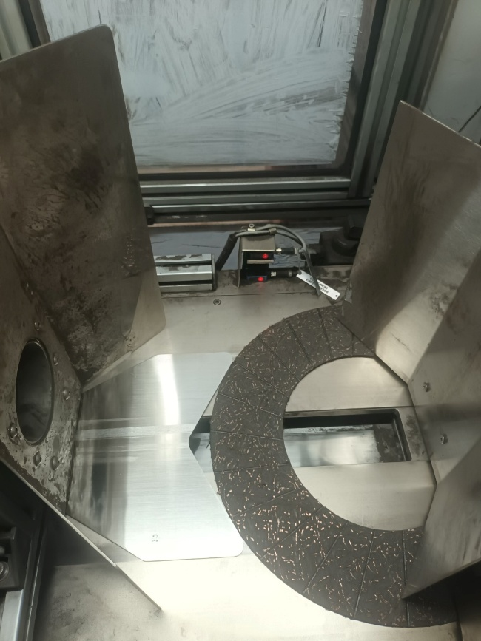

Step 2.1 – Component Feeder Servo Move Forward
- Actor: Festo servo drive (Component Feeder)
- Action:
  - Servo motor receives signal from PLC controller
  - Pushes component forward smoothly toward drill jig center
  - Motion should be controlled and slow (~50–100 mm/sec) to allow settling
- Feedback: Linear position sensor on feeder confirms forward movement
- Timing: 3–4 seconds
- Outcome: Component pushed to center of drill jig

PHASE 3: COMPONENT CENTERING & OVERLAP CHECK (Duration: ~1–2 seconds)
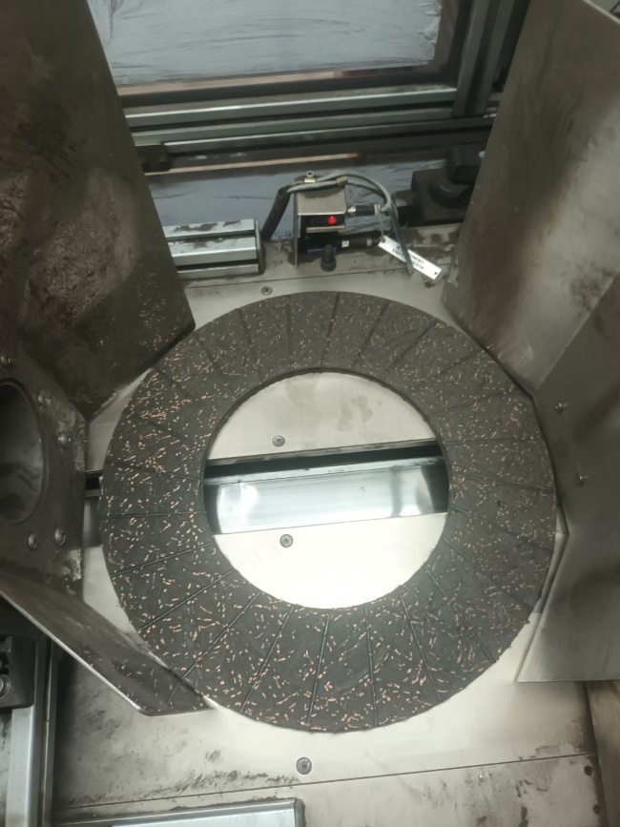
Step 3.1 – Overlap Detection Poka-Yoke Check
- Sensor Location: Above drill jig (height sensor / proximity sensor)
- Action: Sensor detects component height and checks if only ONE component is in jig
- Poka-Yoke Logic:
  - GREEN = single component detected → proceed to next step
  - RED = multiple components detected (overlap condition) → machine stops; alarm sounds; operator must remove overlapped component and restart
- Timing: ~1 second
- Outcome: Single component confirmed in jig; ready for drilling
Step 3.2 – Centering Unit Accuracy Check
- Sensor Location: Centering poka-yoke sensor (points toward component edge)
- Action: Sensor verifies component is centered in jig (radial positioning)
- Tolerance: ±2 mm from jig center (adjustable per part)
- Status:
  - GREEN = component centered correctly → proceed
  - YELLOW = component slightly off-center (within tolerance) → proceed but flag for review
  - RED = component significantly off-center (>2 mm) → machine stops; operator resets and reloads
- Outcome: Component is now centered and ready for drilling

PHASE 4: DRILL HEAD POSITIONING – SERVO MOVEMENT (Duration: ~2–3 seconds)
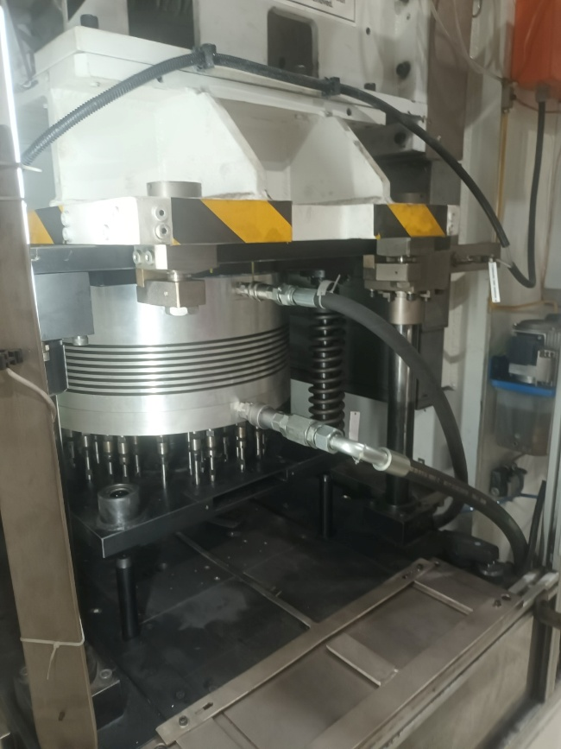
Step 4.1 – Drill Head Servo Move (Downward Positioning)
- Actor: Mitsubishi servo motor + hydraulic servo valve (Drill Head Movement)
- Action:
  - Servo receives signal from PLC
  - Hydraulic actuator lowers drill head smoothly from retracted position (top) toward component
  - Servo control provides smooth, controlled descent at ~100–150 mm/sec
  - Linear position sensor on drill head confirms downward movement
- Timing: 2–3 seconds
- Outcome: Drill head positioned above component, ready for contact
Step 4.2 – Drill Head Contact & Clamping Sequence
- Action:
  - Drill head reaches proximity to component (10–15 mm clearance)
  - Pressure sensor on spindle detects light touch
  - Solenoid valve energizes; hydraulic pressure applies to clamping arms
  - Clamping arms close around component edges, securing it firmly in jig
- Clamping Poka-Yoke Sensor: Confirms clamp is in fully closed position (proximity sensor)
  - Status: GREEN = clamp closed → proceed to drilling
  - Status: RED = clamp stuck or partial closure → machine stops; operator checks for obstruction
- Clamping Pressure: Monitored by pressure sensor; should reach 80–105 BAR within 1 second
  - If pressure does not reach 80 BAR: Poka-yoke alarm; stop cycle; check for leaks
- Timing: 1 second
- Outcome: Component firmly clamped; ready for drilling

PHASE 5: DRILLING CYCLE (Duration: ~4–6 seconds)
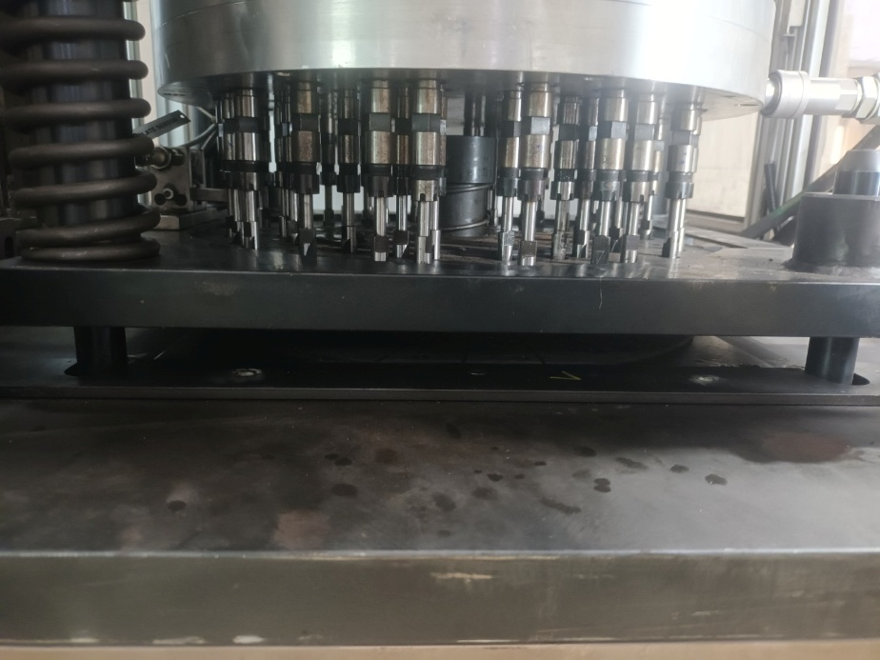
Step 5.1 – Spindle Rotation & Drilling
- Actor: Main spindle motor (1460 RPM) + Multi-spindle gang drill head (48 spindles)
- Action:
  - Spindle motor (3-phase AC induction motor, ~4 kW) energizes to rated speed: 1460 RPM
  - All 48 drill bits simultaneously contact component surface and begin cutting
  - Hydraulic lubrication pump supplies coolant/lubricant at 10 BAR, 30 LPM through drill head
  - Chips and coolant flow downward into dust collection system
  - Servo control monitors spindle load via pressure sensors
- Drilling Process:
  - Hole size: 7.75–14.5 mm depending on part configuration
  - Material: Composite (organic/inorganic fibers + thermoset resin)
  - Feed rate: Automatic servo control (adjusts based on cutting resistance)
  - Coolant: [PLACEHOLDER: Specify coolant type & dilution ratio]
- Monitoring:
  - Spindle current sensor: Should show 60–80% of rated motor current
  - Drill head pressure: Should remain in 80–105 BAR range (servo-controlled)
  - Spindle vibration: Should be minimal (<0.5 mm peak-to-peak) – monitored by accelerometer
  - Acoustic monitoring: Normal drilling sound; no grinding or unusual noise
- Duration: 4–6 seconds (depends on hole depth and material hardness)
- Outcome: All 48 holes drilled successfully through component

PHASE 6: POST-DRILLING POKA-YOKE CHECKS (Duration: ~2–3 seconds)
ss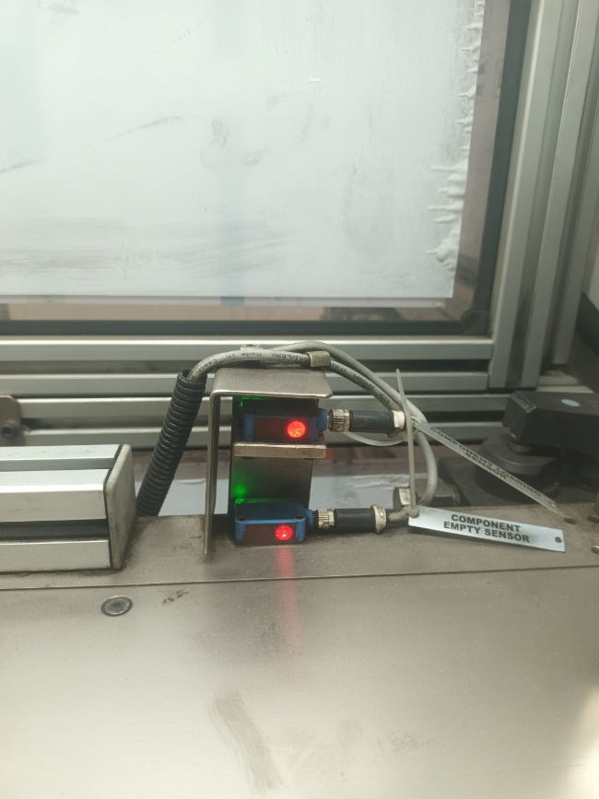
Step 6.1 – Hole Presence Detection
- Sensor Type: Optical/Proximity sensors positioned around component edge
- Logic: Sensor array checks if expected number of holes are present (based on part type)
- Tolerance: ±2 holes acceptable; >2 holes missing triggers alarm
- Status:
  - GREEN = all holes detected → proceed
  - RED = holes missing or blocked with debris → machine stops; operator removes component; investigate cause
- Outcome: Confirmed all holes drilled
Step 6.2 – Concentricity & Hole Position Check
- Sensor Type: Precision concentricity gauging sensor (optical or pneumatic)
- Logic: Measures runout/eccentricity of drilled hole pattern relative to component center
- Tolerance: Maximum 0.8 mm offset (per specification)
- Measurement Method: Sensor scans edge of component after drilling; calculates radial runout
- Status:
  - GREEN = runout <0.8 mm → proceed
  - YELLOW = runout 0.6–0.8 mm → proceed but flag for SPC (Statistical Process Control)
  - RED = runout >0.8 mm → machine stops; component rejected; operator investigates centering
- Outcome: Confirmed hole positioning within tolerance
Step 6.3 – Rivet Hole Thickness Verification
- Sensor Type: Thickness measurement probe (air jet or mechanical)
- Logic: Measures thickness of material surrounding rivet holes
- Tolerance: ±0.05 mm (Critical specification per Valeo)
- Measurement: Automated probe touches each rivet area; compares to stored reference value
- Status:
  - GREEN = thickness within tolerance → proceed to ejection
  - RED = thickness out of tolerance → machine stops; component flagged and held for review
- Outcome: Confirmed dimensional accuracy

PHASE 7: CLAMP RELEASE & COMPONENT FEEDER SERVO BACKWARD (Duration: ~3–4 seconds)
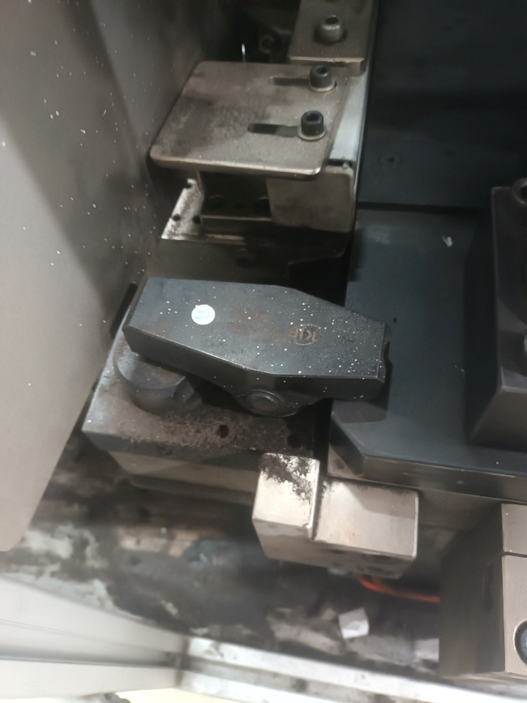
Step 7.1 – Clamping System Release
- Actor: Hydraulic solenoid valve (clamp release)
- Action:
  - Solenoid de-energizes; hydraulic pressure to clamping arms vents to tank
  - Clamp arms spring-open smoothly, releasing component
  - Proximity sensor confirms fully open position (GREEN status)
- Timing: 1 second
- Outcome: Component now loose and ready for ejection
Step 7.2 – Component Feeder Servo Move Backward
- Actor: Festo servo drive (Component Feeder reverse)
- Action:
  - Servo receives reverse signal from PLC
  - Feeder servo pulls drilled component backward (away from jig) at controlled speed ~50–100 mm/sec
  - Component slides out of drill jig into ejection chute
- Timing: 2–3 seconds
- Outcome: Drilled component now positioned for ejection

PHASE 8: DRILL HEAD RETRACTION (Duration: ~2–3 seconds)
[IMAGE PLACEHOLDER: Drill head moving upward to fully retracted position]
Step 8.1 – Drill Head Servo Move (Upward Retraction)
- Actor: Mitsubishi servo motor + hydraulic servo valve (Drill Head Movement)
- Action:
  - Servo receives upward command from PLC
  - Hydraulic actuator retracts drill head upward (away from jig) at ~150 mm/sec
  - Drill head should return to fully retracted position (120–150 mm above jig)
  - Position sensor confirms full retraction
- Timing: 2–3 seconds
- Outcome: Drill head fully retracted; machine ready for next component

PHASE 9: DRILL HEAD DOWNWARD POSITIONING (ALTERNATE PATH) (Duration: ~2–3 seconds)
Step 9.1 – Drill Head Servo Move (Second Station - if applicable)
Note: This step applies only if machine is configured with multiple drilling stations or if component requires secondary drilling operation.
- Actor: Mitsubishi servo motor (alternative drill head position)
- Action:
  - Servo receives command to move to alternate drilling position
  - Hydraulic actuator lowers drill head to second drilling location (if configured)
  - Second set of drilling spindles positions above component
- Note: For single-spindle configuration, skip this step and proceed to Phase 10

PHASE 10: COMPONENT EJECTION & OUTPUT CHECK (Duration: ~1–2 seconds)
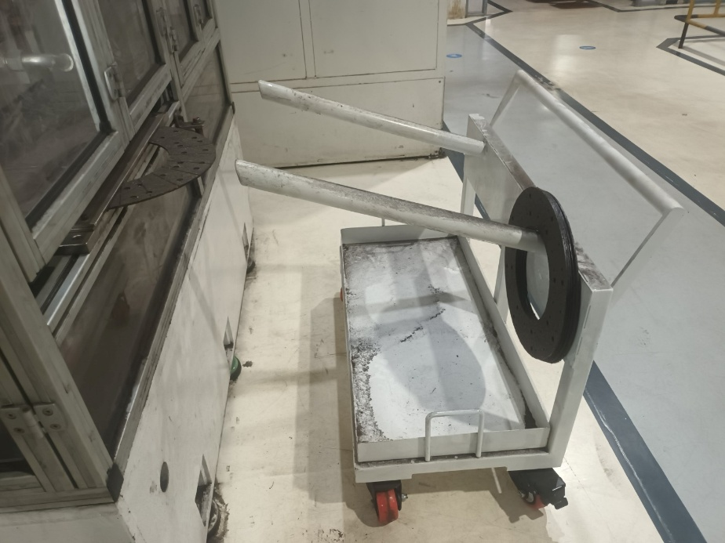
Step 10.1 – Component Ejection from Output Chute
- Actor: Pneumatic ejector pin or gravity-fed chute
- Action:
  - Solenoid-controlled ejector pin (or air jet) activates automatically after feeder retracts
  - Component pushed out of jig and slides down exit chute into collection bin below
  - Gravity and smooth chute surface ensure component reaches output bin without damage
- Timing: 1 second
- Outcome: Drilled component lands in output collection bin
Step 10.2 – Output/Ejection Verification Poka-Yoke Sensor
- Sensor Location: At output chute exit (near collection bin)
- Sensor Type: Presence detector (optical or proximity)
- Logic: Confirms drilled component has successfully exited machine
- Status:
  - GREEN = component detected at output → cycle complete
  - RED = component stuck in chute or missing → machine stops; operator clears obstruction
- Outcome: Component successfully ejected and confirmed in output bin

6.2.3 CYCLE COMPLETION & REPEAT
- Total Cycle Time: ~20–25 seconds per component
- Throughput: 600 components/hour (at full speed)
- Automatic Repeat: Upon successful output verification, machine immediately triggers next component loading
- Cycle continues until:
  - Buffer level drops below minimum (sensor red); machine stops; operator loads more components
  - Emergency stop button pressed; all motion halts immediately
  - Any poka-yoke check fails; machine stops; alarm displayed on HMI
  - Operator presses "STOP PRODUCTION" button on HMI; current cycle completes, then machine stops

6.3 MACHINE STOP PROCEDURES

6.3.1 Normal Stop (End of Shift / Controlled Shutdown)
- Press "STOP PRODUCTION" button on HMI
- Machine completes current component cycle (does not stop mid-cycle)
- Upon cycle completion:
  - Clamp releases
  - Drill head retracts to fully up position
  - Feeder servo returns to neutral
  - Spindle motor de-energizes and coasts to stop (~30–60 seconds)
  - All hydraulic pressures vent safely to tank
  - Pneumatic dump solenoid releases air pressure
- Once machine is completely still (spindle fully stopped):
  - Switch dust collector OFF (if shift ending)
  - Switch main electrical isolator to OFF position
  - Perform end-of-shift checks (Section 6.4)

6.3.2 Emergency Stop (Safety Situation)

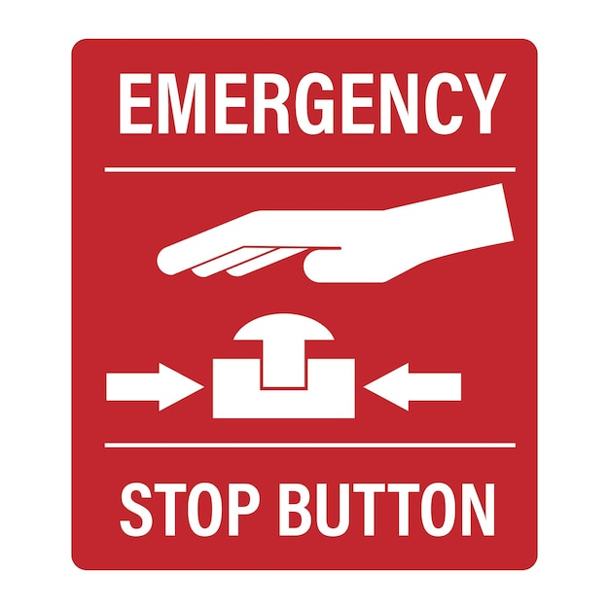
When to Use: Immediate danger, safety hazard, or uncontrolled machine movement
- Press EMERGENCY STOP button immediately – Red mushroom button at operator station
- Effect: All motion stops instantly; spindle cuts off; hydraulics vent; pneumatics dump
- Recovery Steps:
  - Assess situation; identify hazard
  - If hazard eliminated: Turn emergency stop knob clockwise to reset
  - Perform pre-start checks (Section 6.1) before resuming operation
  - If hazard unresolved: Leave E-stop pressed; call maintenance supervisor

6.4 END-OF-SHIFT CHECKS & SHUTDOWN
- Empty Loading Tray – Remove remaining components to storage
- Clean Component Areas – Wipe jig and feeder with clean cloth to remove debris
- Check for Leaks – Visually inspect all hose connections for oil seepage
- Monitor Dust Collector – Empty collection bag if >50% full; this ensures tomorrow's startup suction
- Note any Issues – Record in machine logbook:
  - Any poka-yoke errors encountered during shift
  - Production count and rejection count
  - Any unusual sounds, vibrations, or temperature
  - Maintenance action items for next shift
- Switch OFF Control Systems:
  - Dust collector OFF
  - HMI STOP PRODUCTION button (if still running)
  - Main electrical isolator OFF
- Secure Machine:
  - All safety doors closed and locked (if applicable)
  - Drill head locking pin inserted and locked (safety requirement)
  - No loose components or tools left on machine bed

7. MAINTENANCE & LUBRICATION

7.1 Maintenance Schedule

7.1.1 Daily Maintenance (Before Each Shift)
Task | Procedure | Tool/Material
Visual Inspection | Check for oil leaks, loose fasteners, damage | Flashlight, cloth
Hose Inspection | Inspect all hydraulic and pneumatic hoses for cracks, bulging | Visual only
Dust Collector | Empty collection bag if needed; check filter for blockage | Replacement filter, vacuum
Component Tray | Clean loading area; remove any broken component pieces | Brush, cloth
Drain Plug Check | Verify hydraulic tank drain plug is tight | Wrench (size: [PLACEHOLDER])

7.1.2 Weekly Maintenance (Every 40 Operating Hours)
Task | Procedure | Tool/Material
Hydraulic Fluid Check | Check fluid level in tank; top up if below minimum mark | [PLACEHOLDER: Fluid type]
Pneumatic Filter Cleaning | Clean 5-micron filter element; replace if clogged | Replacement filter, compressed air
Spindle Bearing Inspection | Listen for grinding noise; monitor temperature (should be <50°C) | Thermometer, stethoscope
Servo Motor Check | Verify smooth jog operation of feed servo and drill head servo | Jog buttons on HMI
Sensor Cleaning | Wipe sensor lenses with clean, soft cloth; remove dust | Lens cleaning cloth

7.1.3 Monthly Maintenance (Every 160 Operating Hours)
Task | Procedure | Details
Hydraulic Filter Change | Replace main hydraulic filter element | [PLACEHOLDER: Filter part number]
Lubrication System Check | Check lubrication pump output; verify coolant flow to spindle | Visual verification of mist/flow
Motor Current Draw | Measure spindle motor current under load; compare to baseline | Clamp meter; baseline: [PLACEHOLDER] A
Pressure Gauge Calibration | Verify hydraulic and pneumatic gauges are accurate | Calibration kit; [PLACEHOLDER: Schedule]
Safety Door Testing | Test all safety door interlocks; verify machine stops when opened | Open each door during cycle

7.1.4 Quarterly Maintenance (Every 640 Operating Hours / ~3 months)
Task | Procedure | Details
Gearbox Inspection | Check gearbox mounting bolts; listen for gear noise | Torque wrench; [PLACEHOLDER: Bolt torque spec]
Servo Calibration | Perform servo zero-point calibration per Mitsubishi manual | Mitsubishi service tool required
Poka-Yoke Sensor Calibration | Recalibrate all sensor thresholds per OEM specification | Mitsubishi PLC programming kit
Spindle Alignment Check | Verify spindle runout with dial indicator | Dial indicator; [PLACEHOLDER: max runout]
Electrical Connections | Inspect all terminal blocks and connectors for corrosion | Contact cleaner, dielectric grease

7.1.5 Annual Maintenance (Yearly / ~2500 Operating Hours)
Task | Procedure | Details
Complete Hydraulic System Flush | Drain and replace all hydraulic fluid | Fluid: [PLACEHOLDER]; capacity [PLACEHOLDER] liters
Spindle Bearing Service | [PLACEHOLDER: Bearing type] – check for wear; replace if damaged | Bearing kit; service procedure manual
PLC Battery Replacement | Replace RTC (Real-Time Clock) battery in FX5U controller | Battery type: CR2032; location [PLACEHOLDER]
Safety Certification Renewal | Perform third-party machine safety inspection (Decra/Omron/Pilz) | [PLACEHOLDER: Certifying agency contact]
Coolant System Overhaul | Clean coolant tank; replace any corroded pipes; change coolant | Coolant: [PLACEHOLDER]; quantity [PLACEHOLDER] liters

7.2 Lubrication Specification & Schedule

7.2.1 Hydraulic Fluid Specification
Parameter | Specification
Fluid Type | [PLACEHOLDER: ISO VG 46 Anti-wear Hydraulic Fluid]
Equivalent Brands | [PLACEHOLDER: Mobil DTE 46, Shell Tellus S2 M46, CALTEX RANDO HD 46, etc.]
Tank Capacity | [PLACEHOLDER] Liters
Refill Quantity | [PLACEHOLDER] Liters per refill (check dipstick)
Min/Max Level | Min mark [PLACEHOLDER] cm; Max mark [PLACEHOLDER] cm on sight glass
Change Interval | Every 12 months or 2500 operating hours
Disposal | Collect used fluid in sealed container; send to certified recycler (NOT in drain)

7.2.2 Spindle Lubrication (Coolant/Mist)
Parameter | Specification
Coolant Type | [PLACEHOLDER: Synthetic cutting fluid / mist lubricant]
Dilution Ratio | [PLACEHOLDER: e.g., 1:10 with water]
Supply Pressure | 10 BAR (lubrication circuit)
Flow Rate | 30 LPM (for cooling and spindle bearing lubrication)
Refill Tank Capacity | [PLACEHOLDER] Liters
Refill Interval | Weekly or when sight glass shows low level

7.2.3 Pneumatic System Lubrication
Component | Lubrication Method | Interval
Solenoid Valves | Integrated FRL (Filter-Regulator-Lubricator) on supply line | Every 500 hours
Cylinder Rods | Pre-lubricated at manufacture; minimal additional lubrication needed | Check monthly
Servo Drive Bearings | Self-contained; no field lubrication required | Monitor for noise

7.3 Spare Parts & Consumables List

7.3.1 Critical Spare Parts (Stock Minimum: 2 Units Each)
Part Name | Part Number | Function | Qty | Unit Cost | Lead Time
Hydraulic Filter Element | [PLACEHOLDER] | Removes contamination from hydraulic fluid | 2 | [PLACEHOLDER] | 2–3 days
Pneumatic Filter Element | [PLACEHOLDER] | Removes water and oil mist from compressed air | 2 | [PLACEHOLDER] | 2–3 days
Spindle Bearing Assembly | [PLACEHOLDER] | Supports rotating drill head at 1460 RPM | 1 | [PLACEHOLDER] | 5–7 days
Servo Motor (Festo Feed) | [PLACEHOLDER] | Powers component feeder movement | 1 | [PLACEHOLDER] | 7–10 days
Servo Motor (Mitsubishi Drill Head) | [PLACEHOLDER] | Powers drill head up/down movement | 1 | [PLACEHOLDER] | 7–10 days
Proximity Sensor (Poka-Yoke) | [PLACEHOLDER] | Detects component position, overlap, concentricity | 5 | [PLACEHOLDER] | 3–5 days
Solenoid Valve (Clamping) | [PLACEHOLDER] | Controls clamp open/close | 2 | [PLACEHOLDER] | 2–3 days
Solenoid Valve (Feed) | [PLACEHOLDER] | Controls component feeder direction | 2 | [PLACEHOLDER] | 2–3 days
Hydraulic Hose Assembly (Pressure) | [PLACEHOLDER] | Main pressure line to drill head (105 BAR) | 1 | [PLACEHOLDER] | 3–5 days
Hydraulic Hose Assembly (Return) | [PLACEHOLDER] | Return line from drill head to tank (10 BAR) | 1 | [PLACEHOLDER] | 3–5 days
Pressure Relief Valve | [PLACEHOLDER] | Protects system from overpressure | 1 | [PLACEHOLDER] | 3–4 days
Spindle Drive Belt | [PLACEHOLDER] | Transfers motor power to spindle shaft | 2 | [PLACEHOLDER] | 2–3 days
Coupling (Motor to Gearbox) | [PLACEHOLDER] | Connects motor to gearbox | 1 | [PLACEHOLDER] | 5–7 days

7.3.2 Consumable Items (Reorder as Needed)
Item | Specification | Consumption Rate | Reorder Point
Hydraulic Fluid | [PLACEHOLDER] ISO VG 46 | 5–10 liters/month | 20 liters stock
Spindle Coolant/Mist | [PLACEHOLDER] Synthetic cutting fluid | 2–3 liters/week | 10 liters stock
Pneumatic Filter Elements | 5-micron replacement cartridge | 1 per 500 hours | Always 2 in stock
Drill Bits | Carbide multi-point gang set (48 bits) | [PLACEHOLDER: every X hours/cycles] | [PLACEHOLDER] sets
Safety Door Gasket | Silicone rubber seal, 3mm thickness | 1–2 per year | 2 in stock
Interlock Switch | Magnetic proximity type, 24V DC | 1 per 2–3 years | 1 in stock

7.3.3 Optional Spare Parts (1 Unit Each)
Part | Purpose | Lead Time
Complete Control Panel Module | Full HMI + PLC replacement (emergency backup) | 10–14 days
Spindle Assembly (Complete) | Replacement spindle head if bearing fails | 14–21 days
Hydraulic Pump Unit | Main pump replacement | 10–14 days

7.3.4 Spare Parts Contact & Ordering
Vendor | Contact Info | Typical Response Time
Accurate Machines (Manufacturer) | [PLACEHOLDER: Phone, Email] | 24–48 hours
Mitsubishi Electric (Controls) | [PLACEHOLDER] | 3–5 days
Festo (Pneumatic Components) | [PLACEHOLDER] | 2–3 days
Authorized Distributor (Local) | [PLACEHOLDER] | 1–2 days

8. TROUBLESHOOTING & ALARM CODES

8.1 Common Issues & Solutions

Issue 1: Machine Does Not Start – Green Light Does Not Appear on HMI
Possible Causes:
- Main electrical isolator switch is OFF
  - Check: Verify isolator switch lever points UP (ON position)
  - Action: Switch to ON; observe HMI startup sequence
  - Expected: Mitsubishi logo appears on screen within 5 seconds
- Electrical power supply is not available
  - Check: Verify 3-Phase 415V supply is present at plant distribution board
  - Action: Use multimeter to check voltage at control panel terminal (should read ~415V)
  - Expected: Voltage between 380–440V is acceptable
- Main isolator switch is faulty (stuck)
  - Check: Turn switch slowly; should hear distinct "click" when switching positions
  - Action: Do NOT force; contact maintenance for replacement
  - Expected: Smooth switching action with audible click
- HMI display is powered but not showing startup screen (black screen)
  - Check: Is HMI backlight illuminated? (look at screen in dim light)
  - Action: Press and hold RESET button on HMI for 3 seconds (soft restart)
  - Expected: Mitsubishi logo and main menu should appear within 10 seconds
  - If still blank: Perform cold restart – switch isolator OFF, wait 30 seconds, switch ON again
- UPS (Emergency Stop backup power) has failed
  - Check: If main power lost, does machine still show HMI display for 10 seconds?
  - Action: Check UPS battery indicator light on control panel (should be green)
  - Expected: Green light = battery OK; Red light = battery drained or faulty
  - If red: Contact maintenance to replace UPS battery
Resolution Steps (In Order):
- Check electrical isolator is ON; observe HMI green light
- If no light, perform cold restart (OFF 30 sec, then ON)
- If still no response, use multimeter to verify 3-phase supply at panel
- If supply OK but no HMI: Contact maintenance for control panel troubleshooting

Issue 2: Buffer Sensor Showing Red Light – Machine Stops & Will Not Start Cycle
Possible Causes:
- Minimum buffer level not met
  - Check: Loading tray should contain minimum 100–150 clutch facings
  - Action: Manually load more components into loading tray until red light changes to green
  - Expected: Green light after ~50 components added
- Buffer sensor lens is dirty/dusty
  - Check: Locate buffer sensor (bottom of loading stack); examine lens for dust deposit
  - Action: Gently wipe sensor lens with clean, soft cloth (microfiber preferred)
  - Expected: Red light changes to green; sensor responds to component presence
- Buffer sensor is misaligned
  - Check: Is sensor pointing at component stack, or has it been bumped?
  - Action: Visually inspect sensor mounting bracket; should be perpendicular to stack direction
  - Expected: Sensor should detect light reflection from top component
- Sensor is malfunctioning (electronic failure)
  - Check: Sensor indicator light on sensor body should blink when hand passed over lens
  - Action: If no blink or constant ON/OFF: sensor requires replacement
  - Expected: Blinking indicator = sensor working; steady light = possible failure
  - Next Step: Contact maintenance for sensor replacement (lead time: 2–3 days)
Resolution Steps (In Order):
- Load additional components until buffer light shows green
- If light remains red: Clean sensor lens and retry
- If still red: Check sensor mounting alignment
- If issue persists: Contact maintenance; sensor likely requires replacement

Issue 3: Clamp Will Not Close – Red Light on Clamp Status, Machine Stops
Possible Causes:
- Component is stuck or misaligned in jig
  - Check: Visually inspect component position in jig; should be centered
  - Action: Stop machine; manually remove component; reload carefully
  - Expected: Clamp should close smoothly when component is properly seated
- Clamp mechanical parts are dirty or stuck
  - Check: Move clamp arms manually by hand (machine OFF); should move freely
  - Action: Wipe clamp arms and contact surfaces with clean cloth; remove debris
  - Expected: Clamp arms should move 180° arc freely without sticking
- Hydraulic pressure is not building (clamp solenoid not energizing)
  - Check: Observe hydraulic pressure gauge on manifold during clamping attempt
  - Action: Pressure should rise from 0 to 80+ BAR within 1 second of cycle start
  - Expected: Gauge needle moving upward = solenoid working; needle stuck at zero = problem
  - Next Step: Check solenoid electrical connection; verify 24V supply to solenoid
- Hydraulic leak (reduced pressure, slow clamp closure)
  - Check: Inspect all hose connections around clamp assembly for oil seepage
  - Action: Wipe connections with cloth; if drops visible after 2 minutes, leak confirmed
  - Expected: Dry connections; no visible oil drops
  - Next Step: Tighten connection nuts (use appropriate wrench); if leak continues, replace hose
- Proximity sensor detects false clamp-open position
  - Check: Sensor indicator light should go from red (open) to green (closed) during clamp cycle
  - Action: Manually move clamp to fully closed position; sensor light should go green
  - Expected: Green light = clamp fully closed and locked
  - If light stays red: Sensor may be misaligned or failed; contact maintenance
Resolution Steps (In Order):
- Stop machine; remove component; manually test clamp movement
- Clean clamp arms and contact surfaces
- Reload component carefully; attempt cycle again
- If clamp still won't close: Check hydraulic pressure gauge during clamp attempt
- If pressure low: Check for leaks; tighten hose connections
- If pressure OK but clamp stuck: Contact maintenance for mechanical inspection

Issue 4: Spindle Does Not Rotate – Drill Head Not Spinning at Start of Cycle
Possible Causes:
- Main spindle motor is not receiving 3-phase AC power
  - Check: Listen for motor humming/buzzing sound; should hear audible hum at idle
  - Action: Use multimeter to verify 3-phase voltage at motor terminals (should be ~415V AC between phases)
  - Expected: Approximately 415V between any two phase terminals; 0V on ground-to-phase = fault
  - Next Step: If no voltage, check main contactor on motor starter panel
- Main contactor (motor starter) is stuck open
  - Check: Locate main contactor relay on motor starter panel (usually large black box with 3 terminals)
  - Action: Observe contactor coil indicator light; should illuminate when cycle starts
  - Expected: Coil light ON = contactor energized; coil light OFF = contactor not energizing
  - Next Step: If light OFF, check 24V DC supply to contactor coil
- Spindle motor is mechanically jammed
  - Check: Attempt to manually rotate spindle shaft by hand (machine OFF, E-stop pressed)
  - Action: Grasp spindle shaft or pulley; try to turn gently (should rotate freely with minimal resistance)
  - Expected: Spindle rotates freely; no binding sensation
  - If stuck/grinding noise: Internal bearing failure; stop immediately, contact maintenance
- Spindle thermal overload protection has tripped
  - Check: Feel motor housing with palm – should be warm but not burning hot (<50°C)
  - Action: If motor is very hot, allow 30–60 minutes cooldown with fan running
  - Expected: Motor temperature drops back to <40°C; thermal reset occurs automatically
  - Next Step: If motor keeps overheating on restart, check for bearing friction (grinding noise)
- Variable Frequency Drive (VFD) or soft starter has fault
  - Check: Observe VFD status lights on motor control panel (usually green = OK, red = fault)
  - Action: If red fault light, note the error code displayed (if any); record for maintenance
  - Expected: Green light = normal operation
  - Next Step: Contact maintenance with error code; VFD may require reset or replacement
Resolution Steps (In Order):
- Listen for motor humming sound; if present, spindle driver is energized (power OK)
- If no hum: Check 3-phase voltage at motor using multimeter
- If voltage OK but no spin: Check motor manually; should rotate freely by hand
- If motor stuck: Stop immediately; contact maintenance
- If motor rotates freely but won't run: Check main contactor and motor starter panel
- If all above OK: Contact maintenance for VFD/soft starter diagnostics

Issue 5: Poka-Yoke Sensor Showing Repeated Red Errors – Components Rejected
Possible Causes & Corresponding Poka-Yoke Check:
Error Type A: Groove Poka-Yoke (Component Loading) – Red Light
- Meaning: Component loaded is inverted (no groove detected)
- Cause: Operator placed component upside-down in feeder
- Action:
  - Stop machine
  - Remove inverted component from feeder
  - Reload component with groove facing UP (toward feeder sensor)
  - Groove should be on top surface of component
- Verification: Test with one component; if groove detectable, green light shows
Error Type B: Overlap Poka-Yoke (Drill Jig Entry) – Red Light
- Meaning: Two or more components stacked in jig (height sensor detected overlap)
- Cause: Component not fully ejected from jig before next component entered
- Action:
  - Stop machine
  - Manually remove stacked components from jig
  - Check component feeder servo: should retract fully after each cycle
  - Verify servo air pressure is adequate (5–6 bar minimum)
  - Reload single component; attempt cycle
- Prevention: Ensure pneumatic pressure does NOT drop below 5 bar during operation
Error Type C: Concentricity Poka-Yoke (Hole Position Check) – Red Light
- Meaning: Drilled holes are eccentric (runout >0.8 mm) relative to component center
- Cause: Component centering failed; component was off-center in jig during drilling
- Action:
  - Inspect component loading: Component should sit flush in V-feeder groove
  - Check if V-feeder servo moved fully forward (should push component to jig center)
  - Verify servo position sensor feedback (PLC display should show servo at maximum extension)
  - Check jig centering pins: Should grip component edges without excessive play
  - Re-test with new component batch
- Maintenance Check: If issue persists, centering pins may be worn; contact maintenance
Error Type D: Hole Presence Poka-Yoke – Red Light
- Meaning: Expected holes are missing or blocked; optical sensor did not detect >2 holes
- Cause: One or more spindle bits did not drill; bits may be broken or dull
- Action:
  - Stop machine
  - Inspect drill bits for breakage (broken tips visible)
  - Check spindle speed: Should be exactly 1460 RPM (verify on HMI display)
  - If bits intact and speed OK: bits may be dull (worn); recommend replacement
  - Replace damaged bits with spares from maintenance kit
  - Run test cycle with new bits
- Bit Replacement Procedure: Contact maintenance or experienced operator (specialized tool required)
Error Type E: Rivet Hole Thickness Poka-Yoke – Red Light
- Meaning: Material thickness under rivet area is out of tolerance (±0.05 mm)
- Cause: Component material defect (thinner than specification) OR drill bits cutting too much material
- Action:
  - Inspect failed component: Is it thinner than normal batch?
  - If all components in batch are thin: Reject entire batch; notify material supplier
  - If only isolated failures: Component may have internal voids or delamination
  - Check drill bit wear: Dull bits may cut oversized holes; replace bits
  - Re-test with new bit set
Resolution Steps for Any Poka-Yoke Red Error:
- Stop machine immediately (press STOP PRODUCTION on HMI)
- Identify which poka-yoke check failed (HMI should display error code or description)
- Remove failed component and any subsequent stuck components
- Perform corrective action per error type above
- Clear error by pressing RESET on HMI (should go from red to green)
- Reload component batch; restart production
- If error repeats: Escalate to maintenance supervisor; do NOT force machine to run with repeated errors

8.2 HMI Alarm Codes & Messages
Alarm Code | Display Message | Meaning | Severity | Action
E001 | [PLACEHOLDER: Insert exact message from HMI] | [PLACEHOLDER] | [PLACEHOLDER] | [PLACEHOLDER]
E002 | [PLACEHOLDER] | [PLACEHOLDER] | [PLACEHOLDER] | [PLACEHOLDER]
E003 | [PLACEHOLDER] | [PLACEHOLDER] | [PLACEHOLDER] | [PLACEHOLDER]
W001 | [PLACEHOLDER: Warning codes] | [PLACEHOLDER] | Low | [PLACEHOLDER]
W002 | [PLACEHOLDER] | [PLACEHOLDER] | Low | [PLACEHOLDER]
NOTE: Detailed alarm code table to be populated with ProFace HMI-specific codes from machine commissioning documentation.

8.3 When to Call Maintenance
Situation | Call Maintenance Immediately | Contact Info
Spindle makes grinding noise | YES – Bearing failure likely | [PLACEHOLDER: Emergency contact]
Hydraulic leak (visible oil drops) | YES – System pressure compromised | [PLACEHOLDER]
Electrical shock felt when touching machine | YES – Electrical hazard; E-stop & isolate | [PLACEHOLDER]
Machine vibration increases suddenly | YES – Mechanical imbalance | [PLACEHOLDER]
Repeated poka-yoke errors not resolved | YES – Sensor calibration required | [PLACEHOLDER]
Emergency stop button not resetting | YES – Safety circuit fault | [PLACEHOLDER]
Hose rupture with fluid spray | YES – SHUT DOWN IMMEDIATELY | [PLACEHOLDER]
Control panel smoking or burning smell | YES – EVACUATE & EVACUATE – Fire risk | [PLACEHOLDER]

9. RECIPE PARAMETERS & CONFIGURATION

9.1 Machine Recipe/Program Settings
[IMAGE PLACEHOLDER: HMI recipe menu screen showing all adjustable parameters]
NOTE: The following parameters are programmable via HMI menu. Changes should be made by authorized personnel only (Supervisor or above).
Parameter | Default Value | Range | Unit | Purpose
Spindle Speed | 1460 | 1000–1460 | RPM | Controls drilling speed
Component Feed Rate (Forward) | 50 | 20–100 | mm/sec | Speed of component feeder servo moving forward
Component Feed Rate (Backward) | 50 | 20–100 | mm/sec | Speed of component feeder servo moving backward
Drill Head Descent Speed | 100 | 50–150 | mm/sec | Speed of drill head moving down toward component
Drill Head Ascent Speed | 150 | 50–150 | mm/sec | Speed of drill head retracting upward
Clamping Pressure (Target) | 90 | 70–105 | BAR | Hydraulic pressure for component clamping
Drilling Dwell Time | 4 | 2–8 | Seconds | Time spindle stays in contact with component drilling
Coolant Flow Rate | 30 | 15–30 | LPM | Lubrication system flow to spindle
Cycle Timeout | 60 | 30–120 | Seconds | Maximum time allowed for single cycle before abort
Buffer Minimum Level | 100 | 50–200 | Pieces | Minimum components required in loading tray
Pressure Relief Limit | 105 | 100–110 | BAR | Maximum hydraulic pressure before safety relief valve opens
How to Change a Recipe Parameter:
- Press RECIPES button on HMI main menu
- Select Edit Mode (password required: [PLACEHOLDER: Insert password])
- Navigate to desired parameter using touch buttons
- Press INCREASE or DECREASE to adjust value
- Confirm new value (should show on screen)
- Press SAVE to store in PLC memory
- Press RUN to apply new settings on next cycle
⚠️ WARNING: Never adjust spindle speed above 1460 RPM or clamping pressure above 105 BAR without supervisor approval. These are safety limits set by machine design.

9.2 Calibration & Zero-Point Adjustment

9.2.1 Servo Zero-Point Calibration (Component Feeder)
When Required: If component feeder does not return to starting position (drifts), or if servo moves too far forward/backward
Procedure (Requires Mitsubishi Servo Tool):
- Set machine to SETUP mode on HMI
- Move component feeder servo to fully retracted position (HOME position)
- Connect Mitsubishi servo diagnostic tool to PLC RS-232 port
- Run "Zero Calibration" routine in servo software
- Servo will move forward to mechanical stop, then return to zero position
- Confirm zero position on screen; save in PLC memory
- Test with manual jog commands; verify forward/backward movement is symmetric
[PLACEHOLDER: Detailed Mitsubishi servo calibration procedure document]

9.2.2 Drill Head Servo Calibration
When Required: If drill head does not stop at proper depth, or if servo is not providing smooth up/down motion
Procedure:
- Set machine to SETUP mode
- Connect Mitsubishi servo tool to PLC
- Command drill head to move DOWN slowly; observe when tip reaches component
- Mark reference position on PLC display (zero point for drilling)
- Command drill head to move UP to fully retracted position
- Servo should move exactly same distance in both directions (verify on position display)
- Adjust scaling factor if asymmetric movement detected
- Save calibration; test with manual jog

9.2.3 Poka-Yoke Sensor Threshold Adjustment
When Required: If sensors are falsely triggering errors, or missing legitimate faults
For Proximity Sensors (Presence Detection):
- Access HMI SETUP → SENSOR CALIBRATION menu
- Place reference object (component) at sensor detection zone
- Press TEACH button; sensor "learns" object distance
- Threshold automatically set to trigger 10–20 mm before physical contact
- Test with actual component; verify green light only when component present
For Pressure Sensors (Clamping):
- Pressurize hydraulic system to idle pressure (~30 BAR)
- Access HMI SETUP → PRESSURE THRESHOLDS
- Record baseline pressure reading
- Adjust minimum clamp pressure threshold: Should be 70 BAR (80% of rated 90 BAR)
- Adjust maximum clamp pressure threshold: Should be 105 BAR (relief valve limit)
- System will alarm if pressure exceeds 105 BAR or falls below 70 BAR during clamp
- Save settings

10. APPENDICES

10A. Electrical Wiring Diagram
[IMAGE PLACEHOLDER: 3-Phase supply diagram, motor contactor, emergency stop circuit, 24V DC UPS circuit, PLC connections]
Main Electrical Components:
- 3-Phase 415V AC supply from plant distribution board
- Main isolator switch (16A capacity)
- Motor soft starter or VFD for spindle motor
- 24V DC emergency stop circuit (critical safety circuit)
- UPS battery backup for emergency stop circuit
- Control transformer 415V to 110V (if needed)
[PLACEHOLDER: Detailed electrical schematic to be provided by Accurate Machines technical team]

10B. Hydraulic System Schematic
[IMAGE PLACEHOLDER: Complete hydraulic circuit with pump, relief valve, manifold, clamp and servo circuits, tank]
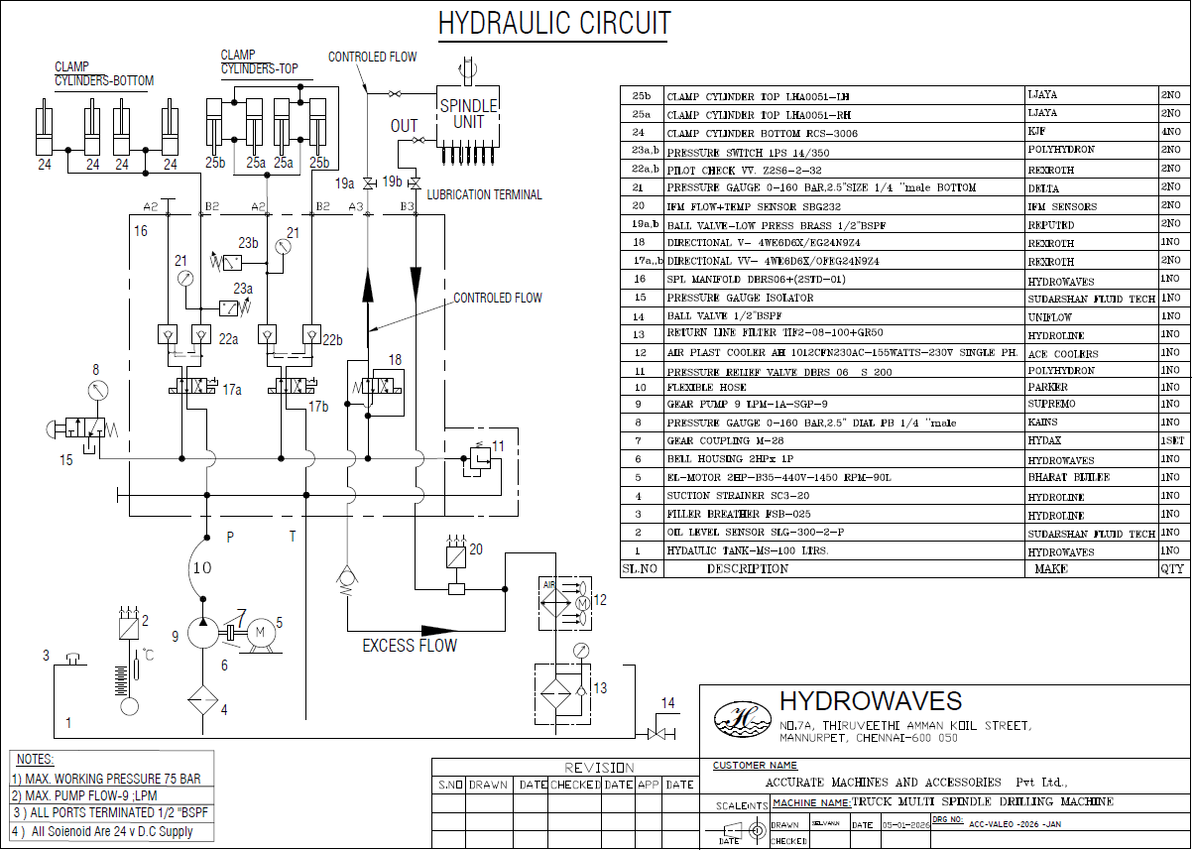
Key Components:
- Hydraulic pump (motor-driven)
- Main relief valve (105 BAR setting)
- Directional control solenoid valves
- Servo-controlled pressure reducing valves (pilot-operated)
- Pressure gauges (main and lubrication circuits)
- Tank with drain and filler plug
- Return line filter
[PLACEHOLDER: Complete hydraulic circuit drawing to be provided]

10C. Pneumatic System Layout
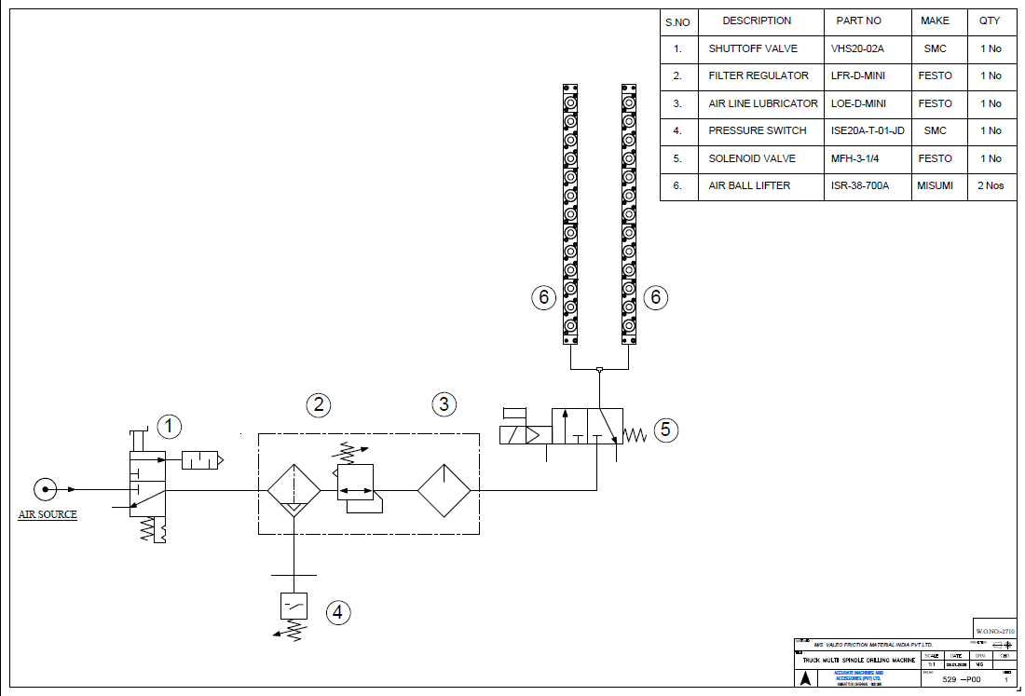
Key Components:
- Plant compressed air source (5–6 BAR)
- Line-mounted 5-micron filter
- Pressure regulator with gauge
- Manual isolation ball valves
- Solenoid dump valve (for LOTO)
- Individual hose runs to Festo servo drives

10D. Machine Dimensional Drawings
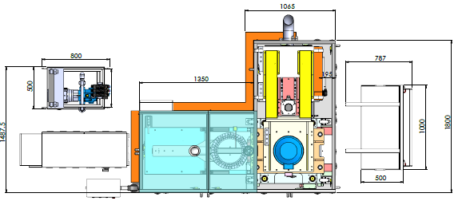
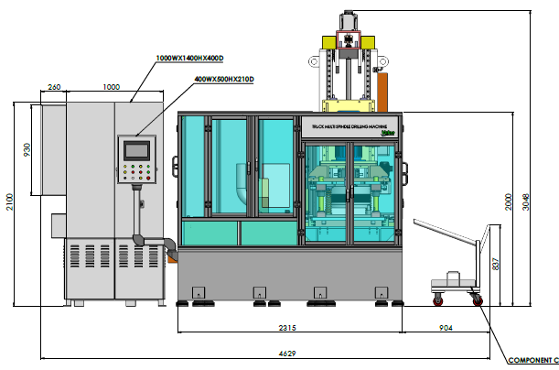
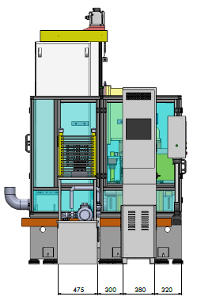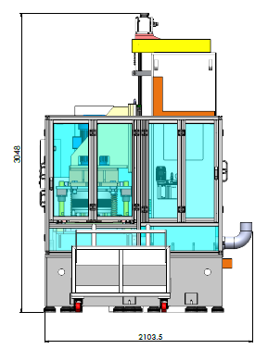
Reference Drawing Number: D/Meth/050/Truck Drilling/CH/01 Rev. 1 (Accurate Machines)

10E. PLC Program Flow Chart
[IMAGE PLACEHOLDER: Complete software flowchart showing main cycle loop, error checking, sensor verification, servo movement sequencing]
PLC Controller: Mitsubishi FX5U Series
Scan Time: 10 ms (100 cycles per second)
Backup Battery: CR2032 (RTC battery)
Program Size: [PLACEHOLDER]

10F. Component Specifications & Tolerances
Clutch Facing Dimension Reference (Per Valeo D/Meth/025 Rev. 12):
Dimension | Mini | Maxi | Tolerance
Outer Diameter | 280 mm | 430 mm | ±0.5 mm
Thickness | 2.8 mm | 6.2 mm | ±0.2 mm
No. of Holes | 24 | 54 | Exact count
Hole Diameter | 7.75 mm | 14.5 mm | ±0.1 mm
Hole Position Runout | — | — | Max 0.8 mm
Rivet Hole Thickness | 0.9–2.1 mm | — | ±0.05 mm

10G. Safety Data Sheet (SDS) Placeholders
Hydraulic Fluid SDS:
[PLACEHOLDER: Link or attachment to hydraulic fluid safety data sheet]
Spindle Coolant SDS:
[PLACEHOLDER: Link or attachment to cutting coolant safety data sheet]
Pneumatic Compressor Oil SDS:
[PLACEHOLDER: Link or attachment to pneumatic oil safety data sheet]

10H. Machine Operating Log Template
Date | Shift | Operator Name | Start Time | End Time | Total Parts Produced | Rejected Parts | Defect Code | Maintenance Actions | Supervisor Sign
[PLACEHOLDER] | [AM/PM] | [NAME] | [HH:MM] | [HH:MM] | [Number] | [Number] | [Code] | [Description] | [Sign]

10I. Machine Maintenance Log Template
Date | Maintenance Task | Duration (mins) | Components Replaced/Serviced | Technician Name | Parts Cost | Status (Complete/Pending)
[PLACEHOLDER] | [Task description] | [Minutes] | [Parts] | [Name] | [Amount] | [Status]

10J. Accident/Incident Report Form
Machine Incident Report – Truck Drilling Machine
Date & Time: ______________
Location: ______________
Operator Name: ______________
Operator ID: ______________
Incident Type (Circle):
- Minor Injury | Serious Injury | Equipment Damage | Near-Miss | Other
Description of Incident:
Root Cause (If Known):
Immediate Action Taken:
Witness Names & Signatures:
- ______________ Signature: ______________
- ______________ Signature: ______________
Supervisor Review & Comments:
Supervisor Signature: ______________ Date: ______________
Machine Status After Incident (Circle):
- Operational | Minor Repair Needed | Out of Service | Requires Safety Inspection

10K. Glossary of Terms
Poka-Yoke: Japanese term meaning "mistake-proof" or "fool-proof." Automatic error detection system that stops machine if abnormal condition detected.
Servo Motor: Precision electric motor that responds to PLC commands for precise position/velocity control (used for component feeder and drill head movement).
Solenoid Valve: Electromagnetic device that opens/closes fluid passages when energized (used for clamping, feeding, and air control).
MTBF (Mean Time Between Failures): Average operating time between equipment breakdowns (target: 8 hours minimum for this machine).
TRP (Total Run Percentage): Percentage of scheduled operating time that machine actually runs without stoppage (target: 85% minimum).
MTTR (Mean Time To Repair): Average time required to fix machine after failure (target: maximum 1 hour).
Proximity Sensor: Non-contact sensor that detects object presence/position using electromagnetic or optical technology.
LOTO (Lock-Out/Tag-Out): Safety procedure to isolate energy sources and prevent accidental machine restart during maintenance.
Runout: Amount of deviation from perfect concentricity; measured as radial distance from true center (tolerance: 0.8 mm maximum).
Eccentricity: Off-center condition of a circular component; detected by concentricity poka-yoke sensor.

10L. Emergency Contact Numbers
Contact Type | Name | Mobile | Email | Availability
Manufacturer (Technical Support) | [PLACEHOLDER] | [PLACEHOLDER] | [PLACEHOLDER] | [PLACEHOLDER]
Maintenance Supervisor | [PLACEHOLDER] | [PLACEHOLDER] | [PLACEHOLDER] | 24/7 (on-call)
Plant Safety Officer | [PLACEHOLDER] | [PLACEHOLDER] | [PLACEHOLDER] | 24/7 (on-call)
Electrical Technician | [PLACEHOLDER] | [PLACEHOLDER] | [PLACEHOLDER] | Business hours
Hydraulics Specialist | [PLACEHOLDER] | [PLACEHOLDER] | [PLACEHOLDER] | Business hours
Plant Emergency Services | [PLACEHOLDER] | [PLACEHOLDER] | [PLACEHOLDER] | 24/7
Poison Control / Medical | [PLACEHOLDER] | [PLACEHOLDER] | [PLACEHOLDER] | 24/7

10M. Training Certification Record
Employee Name: ______________
Employee ID: ______________
Department: ______________
Training Date: ______________
Trainer Name & Signature: ______________
Training Topics Completed (Check):
- [ ] Machine Safety & Hazard Awareness
- [ ] Emergency Stop & LOTO Procedures
- [ ] Pre-Start Verification Checklist (Section 6.1)
- [ ] Normal Operating Cycle (Section 6.2)
- [ ] Troubleshooting Common Issues (Section 8.1)
- [ ] Maintenance Schedule & Procedures (Section 7)
- [ ] Poka-Yoke Error Codes (Section 8.2)
- [ ] Component Loading & Quality Verification
- [ ] Equipment Shutdown & End-of-Shift Procedures
- [ ] Hands-On Practical Training (Supervised)
Trainer Assessment: (Circle)
PASS – Employee demonstrates competency in all areas
CONDITIONAL PASS – Employee requires additional supervision in: ______________
NOT READY – Further training required; retest scheduled for: ______________
Trainer Signature: ______________ Date: ______________
Plant Supervisor Sign-Off (Authorization to Operate Independently):
______________ Date: ______________

DOCUMENT CONTROL
Version | Date | Changes Made | Author | Approved By
1.0 | January 2025 | Initial document creation | [PLACEHOLDER] | [PLACEHOLDER]
[FUTURE] | [TBD] | [TBD] | [TBD] | [TBD]
Document Custodian: [PLACEHOLDER: Maintenance Manager / Plant Engineer]
Next Review Date: January 2026
Distribution: Digital copy on plant intranet; printed manuals at operator stations

END OF MANUAL
For questions or clarifications, contact: [PLACEHOLDER: Manufacturer support details]

